|  |
| --- |
| ABSTRACT |

PTSS Live Scoreboard is an effective system that can be used to assisted a sport officer to manage data for sport games. This system is specially designed to provide facilities to sports centers in educational institutes such as PTSS that do not yet have such a system. In addition, to facilitate a sport officer or referee to keep track of each point earned by each team.

According to the information available, most people use paper to record data matches. This research and findings are very important in changing the way sports data and information management is organized. In fact, the system has many functions, which work on displaying scoreboard through live broadcasts, updating points of entry for all contests simultaneously by referees and managing data score games or live match points using the web with databases.

Furthermore, the Politeknik Malaysia is using the concept of POLYgreen. So, to support this programme, this project is well-developed as it can save paper usage. As an excuse, sport officer no longer need to record data on paper. They just need to use this system and they can apply the POLYgreen concept. Other than that, it is also useful for the spectators, where they no longer need to be disappointed if they are unable to keep up with their favorite team match points. They only need to visit the PTSS Live Scoreboard website to find out the match points.

In conclusion, this system and the hardware used are very useful for everyone. With the help of networking, everyone can access the PTSS Live Scoreboard website and can apply the concept of POLYgreen .

**Keywords:** Assisted sport officer, provide facilities to sports centers .

# TABLE OF CONTENTS:

ABSTRACT 1

TABLE OF CONTENTS: 2

List Of Figures 4

List Of Table 5

Chapter 1: 6

Project Plan 6

1.1 Introduction 6

1.3 Objective of Project 7

1.4 Scope of Project 7

i) System Scope 7

ii) User Scope 7

iii) Location Scope 7

1.5 Literature Review 8

1.6 Methodology of Project 11

Chapter 2 12

Requirement Specification 12

2.1: Functional Requirement 12

2.2: Non-Functional Requirement 23

2.3: Hardware and Software Requirement 23

2.4: System Configuration 25

**2.4.1: System configuration for Raspberry Pi** 26

**2.4.2 System Configuration for Web System** 27

CHAPTER 3 42

FINAL DESIGN 42

3.1 Logical Design 42

3.1.1 Flow Chart 43

3.1.2 Functional Decomposition Diagram (FDD) 44

3.2 Physical Design 46

CHAPTER 4 57

Test Description and Results 57

4.1 Unit Testing Plan 57

4.2 Integration Testing Plan 58

CHAPTER 5 59

Major Findings and Discussion 59

5.1 Advantages of the Project 59

5.2 Limitation of the Project 59

CHAPTER 6 60

Conclusion and Recommendations 60

# List Of Figures

Figure 1.5. 1 Portable Electronic Scoreboard for Officiating a Sporting Game. 8

Figure 1.5. 2 Multi-sport LED Scoreboard with Wireless Communication 9

Figure 1.6. 1 SDLC Diagram 10

Figure 2.1. 1 Main interface of PTSS Live 11

Figure 2.1. 2 Interface for 'About' page. 12

Figure 2.1. 3 Interface match schedule football 12

Figure 2.1. 4 Interface match schedule netball 13

# List Of Table

Table 2.3. 1 Hardware Requirement 22

Table 2.3. 2 Software Requirement 23

# Chapter 1:

# Project Plan

## 1.1 Introduction

Nowadays, polytechnics have scoring problems for one or more ongoing sports matches. This may result in loss of scoring data. The PTSS Live Scoreboard will developed at Politeknik Tuanku Syed Sirajuddin to be used to facilitate sports officer or sports referees to monitor every point in each team. In addition, this system displays point for each game that allows viewers to watch anywhere through the website. The audience or spectators will not miss any of the ongoing sports scoring.

Next, the system is controlled by a match panel or an administrator that updates the match point on the website system. This system uses a Raspberry Pi 3 Model B as a terminal to display match points on television screens. Through this game, the launch of the match can be done effectively.

1. **Problem Statement**

Sport Centre of Politeknik Tuanku Syed Sirajuddin (PTSS) is organizing various sports events each year. But there are still certain issues that interfere with the smooth running of sports matches that may affect the audience and the organizers. Some of the issues that arise when the audience is hard pressed to figure out the match points during each live game of the team. This happens when there are spectators who cannot attend the event or those who want to see what the match has been and is going on.

The next problem is, sports officer manually collect points after finish game. The system used has a negative effect on the game as it will cause confusion in managing the match points as well as the team playing.

Furthermore, a system sports center does not exist system that can control match's points updates for all matches simultaneously. This will result in delays when delays for the referee give match points to the system being used as multiple matches are played at a time.

Therefore, PTSS Live Scoreboard is recommended to the PTSS Sports Centre for use. This is because the system provides a simpler and easier way for sports officer to organize sports matches.

## 1.3 Objective of Project

The objective of this project are:

* To manage the data score games or live match point using web with database.
* Easy to view the match points of each team's game through television or monitor screen.
* Facilitating the sport officer to collect points for one or more ongoing game.

## 1.4 Scope of Project

### i) System Scope

This system is only performed by sports personnel and sports referees. Each addition or subtraction of the score will be updated by the sports officer while the update score will be made by the sports referee. Viewers can go to the website built to see the latest match points and be able to watch the match going on.

### ii) User Scope

There is three scope of users allowed to use this system which are sport officer, sport referees and spectators. Sport officer as an administrator to update and edit match points. While, the sports referee updates each score in each game while the spectators can see the match point through the website or television screen.

### iii) Location Scope

The location scope of this project is at Department of Sports, Curriculum and Culture Politeknik Tuanku Syed Sirajuddin, Perlis Malaysia. The collaboration of this institute of education is very meaningful to this project. All the idea of improvement received from this investigation will be upgraded to launch this project.

## 1.5 Literature Review

1. Portable Electronic Scoreboard for Officiating a Sporting Game.

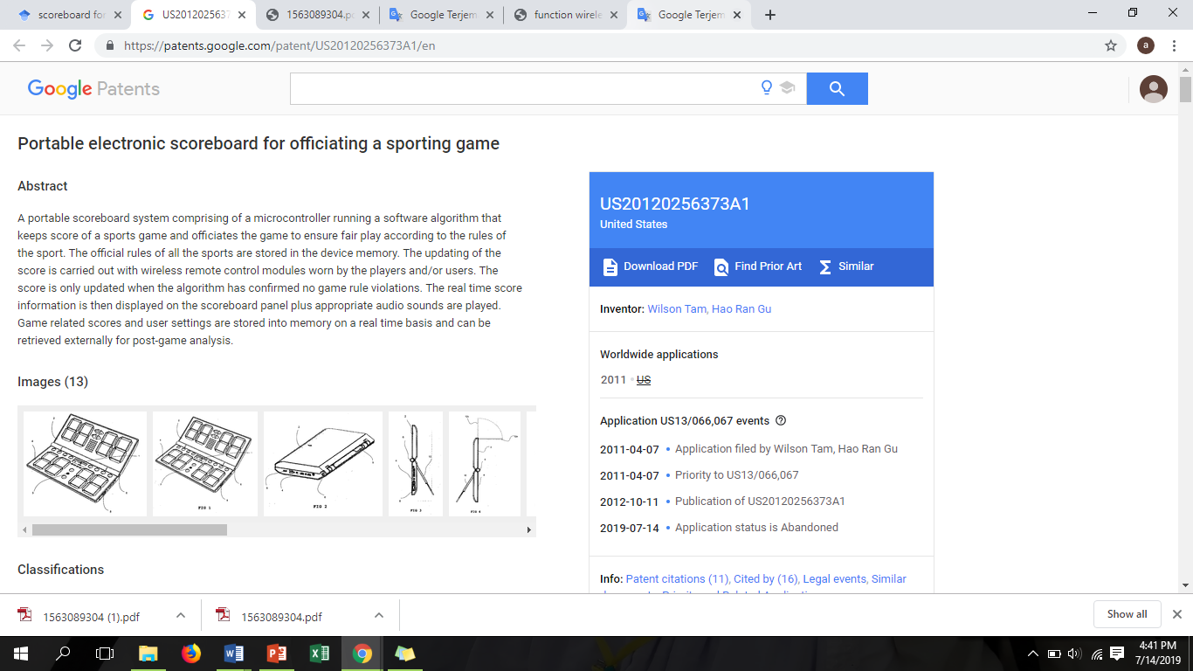

Figure 1.5. 1 Portable Electronic Scoreboard for Officiating a Sporting Game.

A portable scoreboard system comprising of a microcontroller running a software algorithm that keeps score of a sports game and officiates the game to ensure fair play according to the rules of the sport. The official rules of all the sports are stored in the device memory. The updating of the score is carried out with wireless remote control modules worn by the players and/or users. The score is only updated when the algorithm has confirmed no game rule violations. The real time score information is then displayed on the scoreboard panel plus appropriate audio sounds are played. Game related scores and user settings are stored into memory on a real time basis and can be retrieved externally for post-game analysis.

1. Multi-Sport LED Scoreboard with Wireless Communication







Figure 1.5. 2 Multi-sport LED Scoreboard with Wireless Communication

The entire built-in scoreboard will be used for, ideally, various sports leagues across the country. The reason for the potential success is because of how the system is set up. The system will have multiple ways to control the scoreboard, while still light and portable to use on many different events along the reach of sports leagues. Another big bonus is the scoreboard can be used as a scoreboard for not just a particular sport but for a variety of sports that can be held.

Multi-Sport Board (Andrew Cody Cooke, 2001) scores part of this project will be the most prestigious for the team as the size will be available upon completion. In all these boards need to insert a 64 or 128 pin microprocessor to run devices that have the ability to interpret the selected Bluetooth protocol. This microprocessor will then be the brain of the device that controls all seven segmented and individual LED exhibits. This task will be prepared by using seven segment guides that read binaries and translate them to pin in seven segment views. The board will also interpret the type of board used, the sport is played.

This is mainly handled by a laptop or tablet. Remote control will be the smallest physical item delivered. Remote controller will be a small device with minimal control with just 1 or minus 1 scoreboard, start and stop time, and choose sport. The main controller for this will be a laptop or tablet because custom controls are available, but the functionality will be the same as that can be used with remote control as well.

Mobile apps will be a way to control this device. The graphical user interface (GUI) will have a scoreboard image as it will be shown on the actual scoreboard. This image also has a different button pattern depending on which sport, for example if basketball is being played, it will add 1, 2, or 3 and the minus 1 button used to change the score. It also includes all-time controls with start button and stop time, out time and place with Piezo buzzer. It will also have a drop down menu at the top to choose between sports / sports played.

This feature to the product is considered an option at this time. An online database will be the way for viewers to get the latest scores for the game being hosted. Mobile apps and laptops; as both have the ability to connect to the web, will upload scores to an online database accessible to smartphones available in the world. This function is for laptops or tablets to connect to fans, publishing game track scores, and always refreshing that every few minutes or so. After a mobile device like a smartphone or other computer will be able to ping this database and pull the game's score in progress.

Table 1.5. 1 Table of Comparison

|  |  |  |  |
| --- | --- | --- | --- |
|  | Portable Electronic Scoreboard For Officiating A Sporting Game. | Multi-sport LED scoreboard with wireless communication | PTSS Live Scoreboard |
| Database |  |  |  |
| Raspberry Pi Model B |  |  |  |
| Arduino |  |  |  |
| Manual update |  |  |  |
| Graphic user interface (GUI) |  |  |  |

## 1.6 Methodology of Project

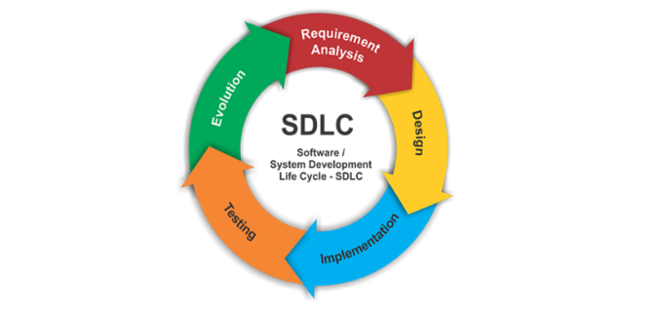

Figure 1.6. 1 SDLC Diagram

**Phases 1: Requirement analysis.**

The requirement is the first stage in the SDLC process .This project is carried out by collecting information through observations and interviews. Observations and interviews were made in my sporting Department, Curriculum and Polytechnic Culture Syed Sirajuddin and watch manual scores. A sports official has been interviewed on the scoreboard available at PTSS. From the gathered information, we will set the standard that the finished product will adhere to.

**Phases 2: Design**

Once the requirement analysis phases is completed the next step is to define and document software and hardware needs. This project uses the software used is Visual Studio Code, PHP and HTML. Database using MySQL, Xampp to store every updated data.

**Phases 3: Implementation**

Once the system design phase is over, the next phase is coding .in this phase, developers start build the entire system by writing code using the PHP programming language.

**Phase 4: Testing**

Once the system is complete, and it is deployed in the testing environment. Team starts testing the functionality of the entire system. This is done to verify that the scoreboard system works according to the customer requirement and the objective.

**Phase 5: Evolution**

The final phase is to measure the effectiveness of PTSS Live Scoreboard and evaluate potential enhancements. Most education institute are in production for several years. During this time, the system must evolve to meet the changing requirements. This evolution of the system will continue until it is finally replaced by a new system.

# Chapter 2

# Requirement Specification

**Introduction**

In this chapter, it contains sub chapter that is functional requirement, non-functional requirement, and hardware and software requirement. Requirement specification is a set of documentation that describes the features and behavior of a system or software application. It includes a variety of elements that attempts to define the intended functionality required by the customer to satisfy their different users.

## 2.1: Functional Requirement

* Sport officer can register referee and team easily using system.
* Referee use a system to key in point.
* The spectators can easily access into the website to view the live scoreboard.
* The system should allow users (viewers) to access into the web.
* Only Sport Officer have the right to register team and referee.
* The software system should be integrated with point controller that control by the referee.

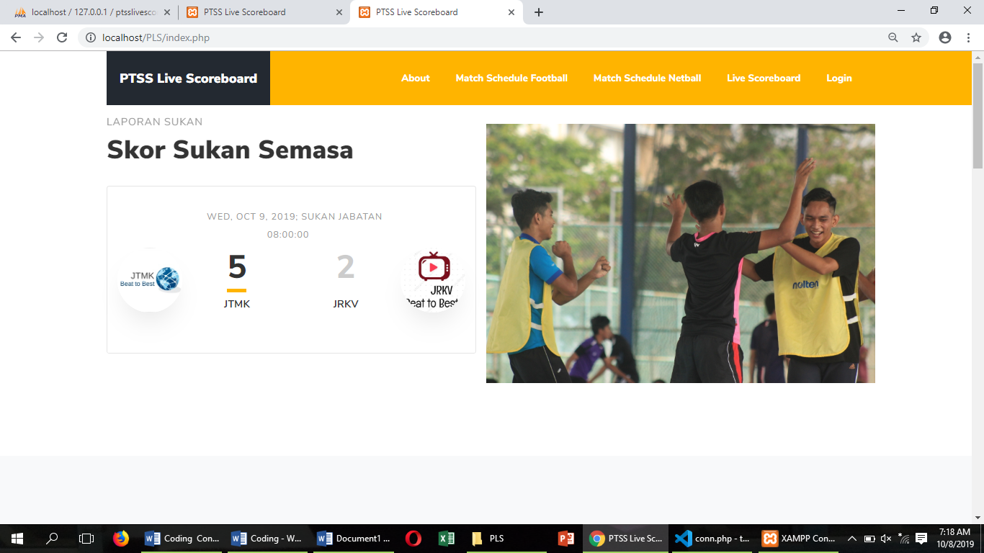

Figure 2.1. 1 Main interface of PTSS Live

This home page contains current sports scores and is related to ptss live scoreboard info.

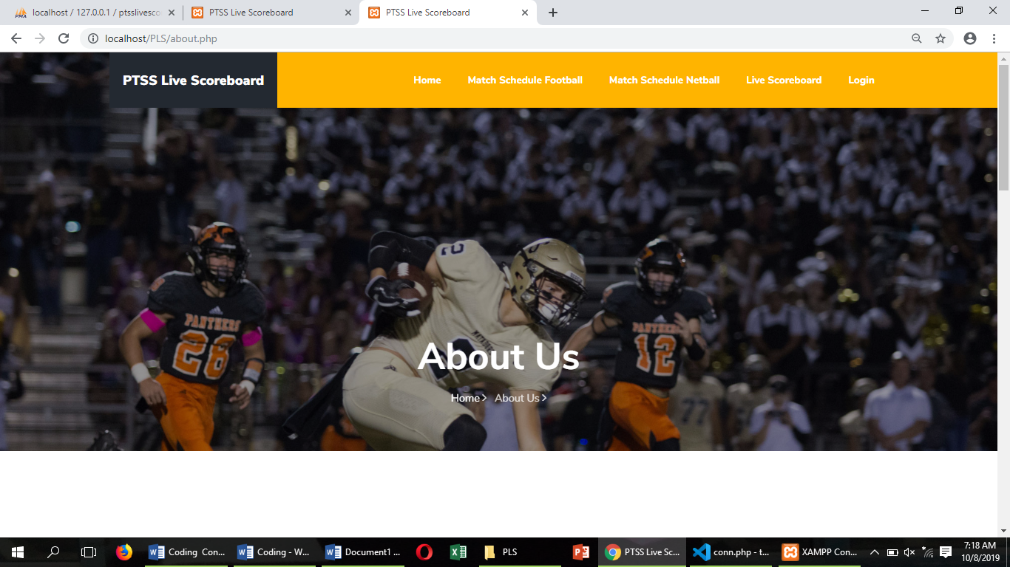

Figure 2.1. 2 Interface for 'About' page.

This is the main page for PTSS Live Scoreboard. This page could be access by everyone and there are several menu to be choose which is Home, About, Match Schedule, All Result, Live Scoreboard and Login.

'Home' on the menu is the first page everyone will see. This page contains recent sports scores. While the 'About' page contains information such as the developer of the web site. In addition, this page also tells the background of the system. The 'All Result' page will tell visitors the overall score for the match that has taken place. In addition, the 'Match Schedule' page will display the match schedule for the upcoming game. In the meantime, there is also a 'Live Scoreboard' page where it will show the match points. Finally, there is a selection button on the menu that is 'Login'. Only sport officer and referees will choose the menu.

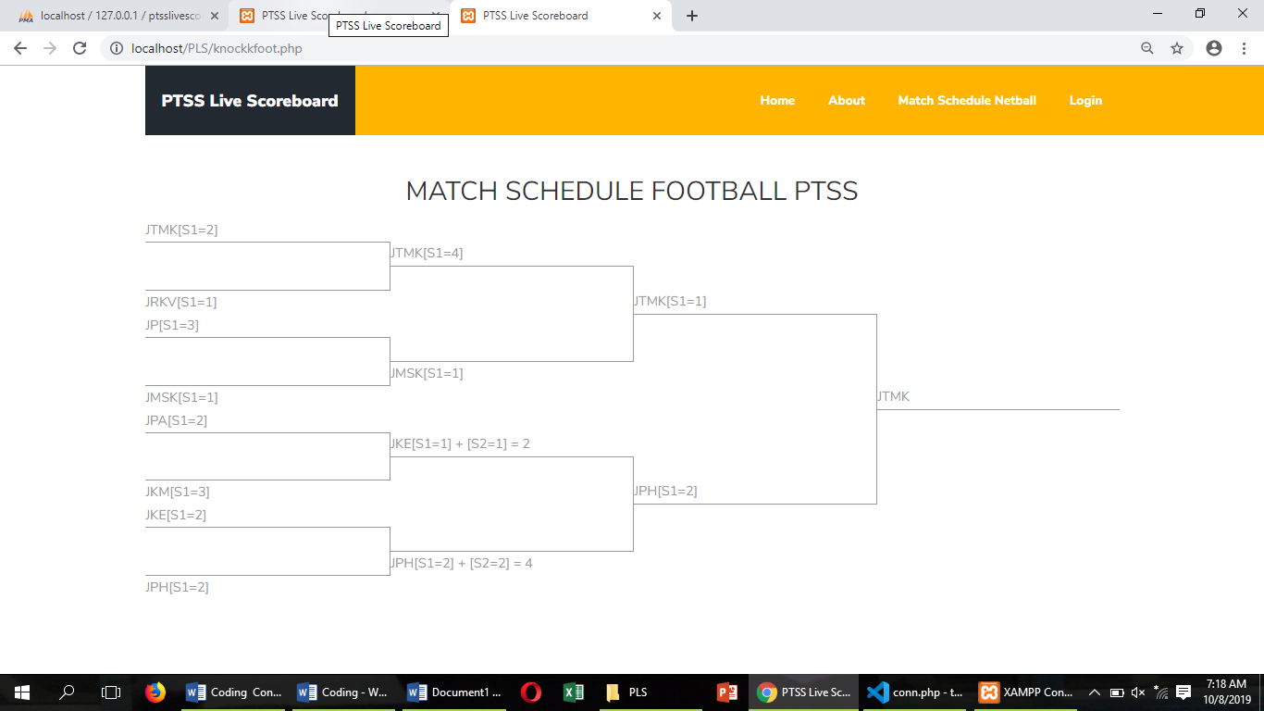

Figure 2.1. 3 Interface match schedule football

This match schedule page will display the scores according to the points obtained by the opposing team. 8 teams will fight and 4 teams will win the semi-finals. If they finish in the semi-finals the 2 teams will compete in the final and the winner of the final round will be recognized for the match.

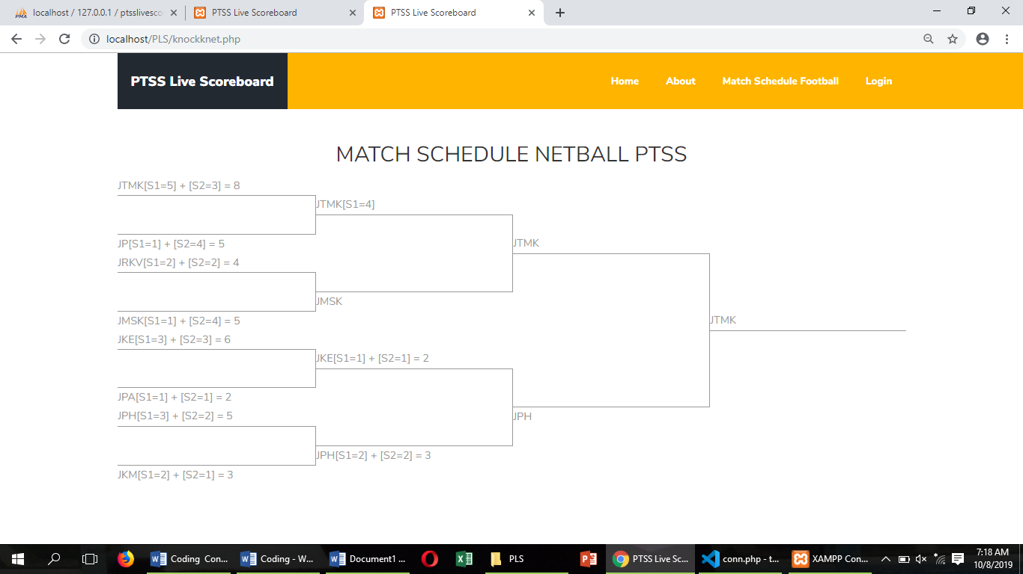

Figure 2.1. 4 Interface match schedule netball

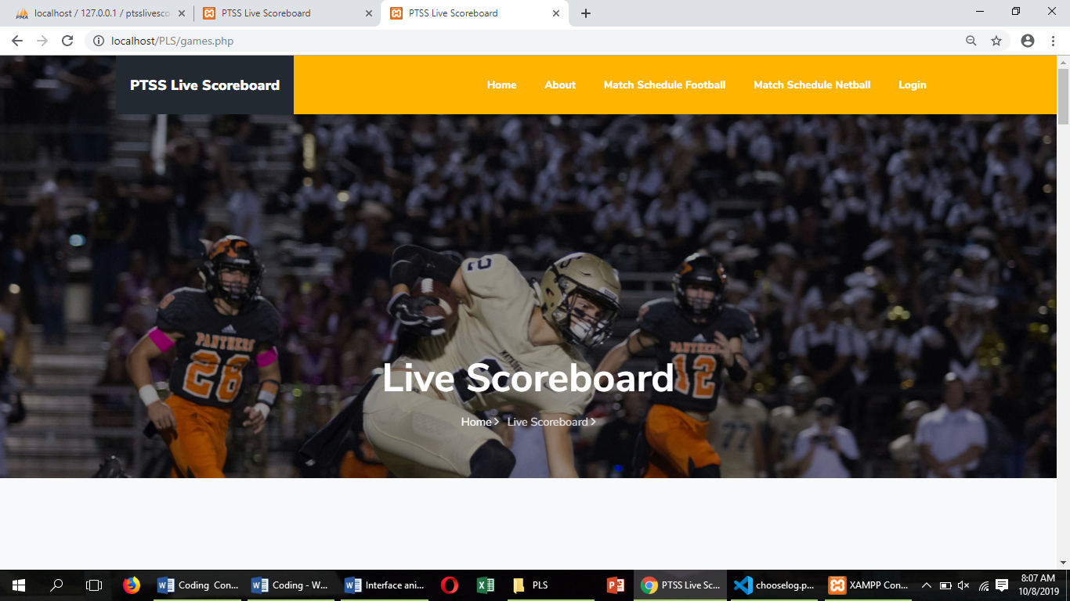

Figure 2.1 1 Interface for Livescoreboard

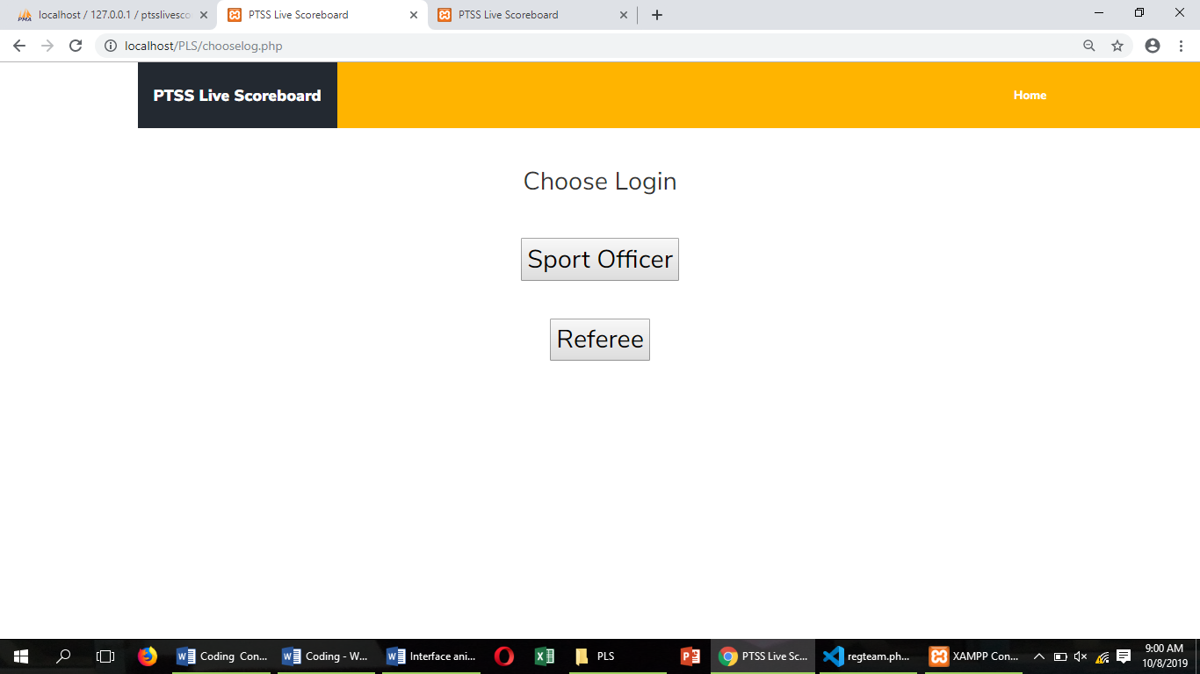

Figure 2.1 2 Interface choose login

This page is for sport officers and referees to log into their respective sections. Only a sport officer can enter the page for a sport officer. In order to login, the referee who has been registered by the sport officer will be able to login.

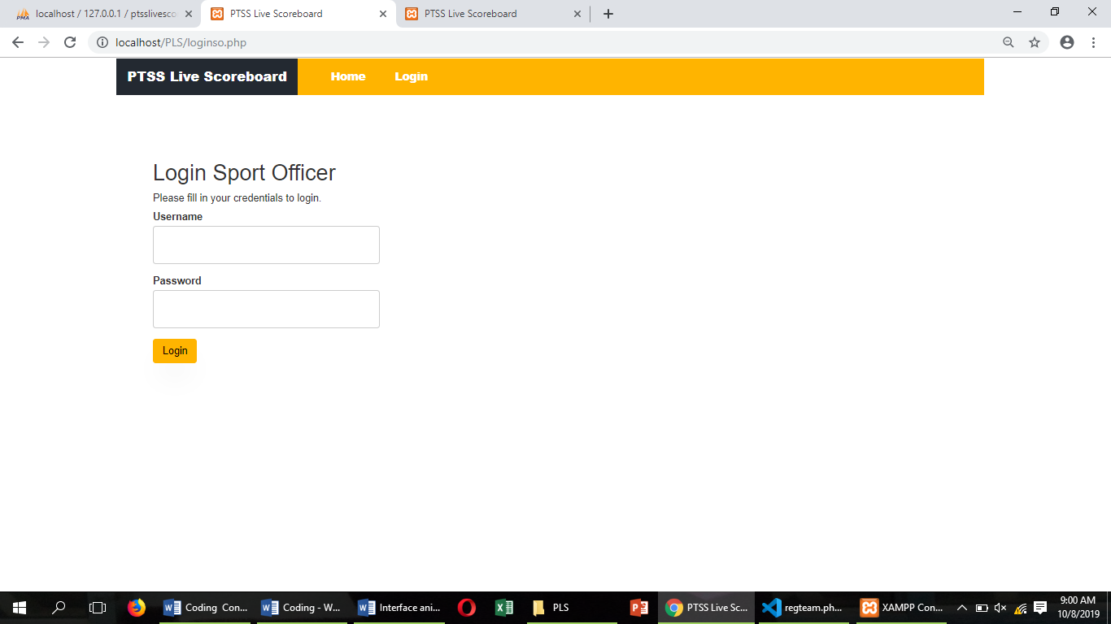

Figure 2.1 3 Interface login sport officer

This page will be managed by a sports official. The sport office will sign a referee who will perform the task. All the information for the registry is filled out by sports personnel.

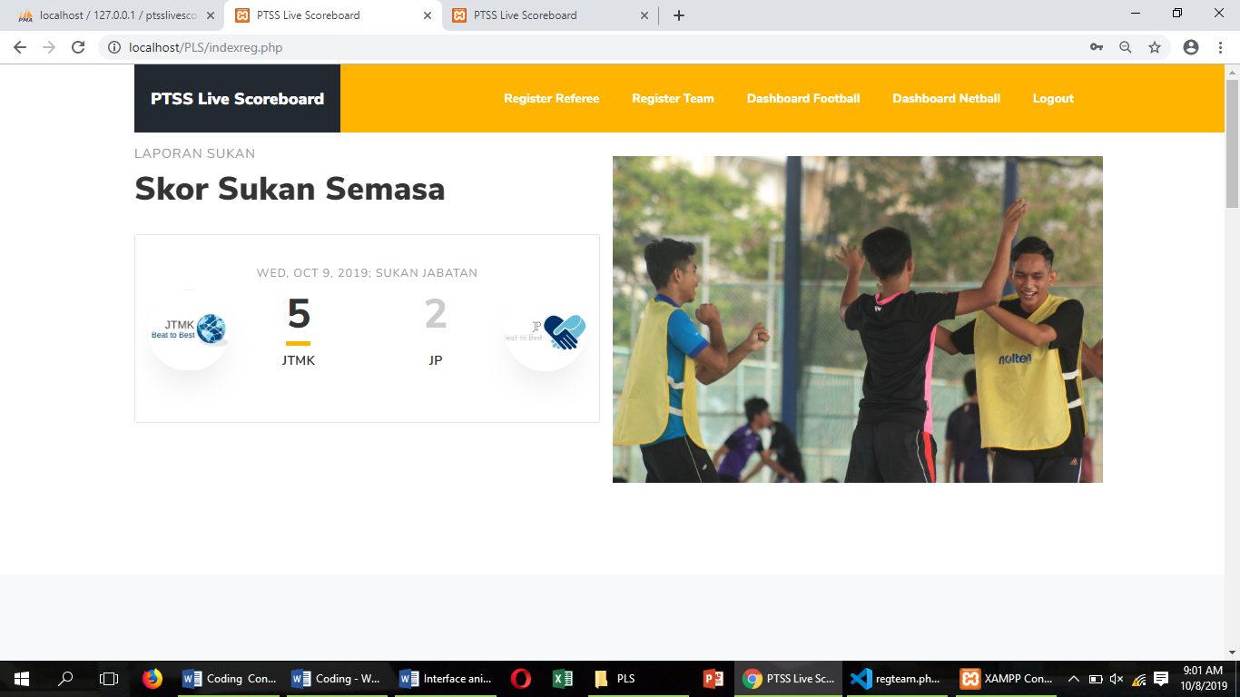

Figure 2.1 4 Interface for sport officer

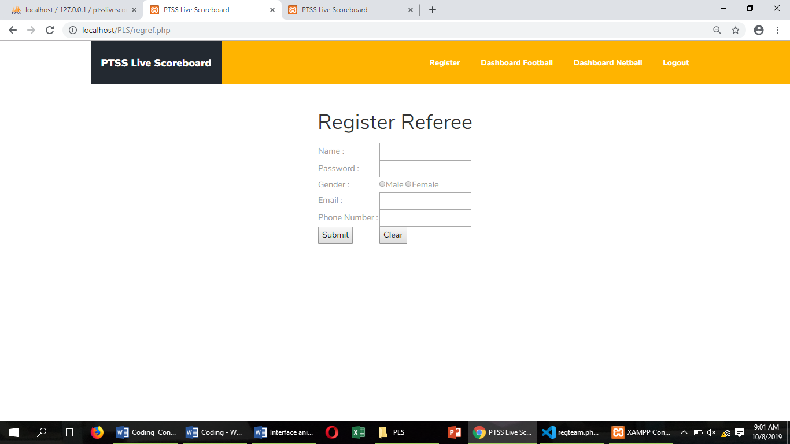

Figure 2.1 5 Interface for register referee

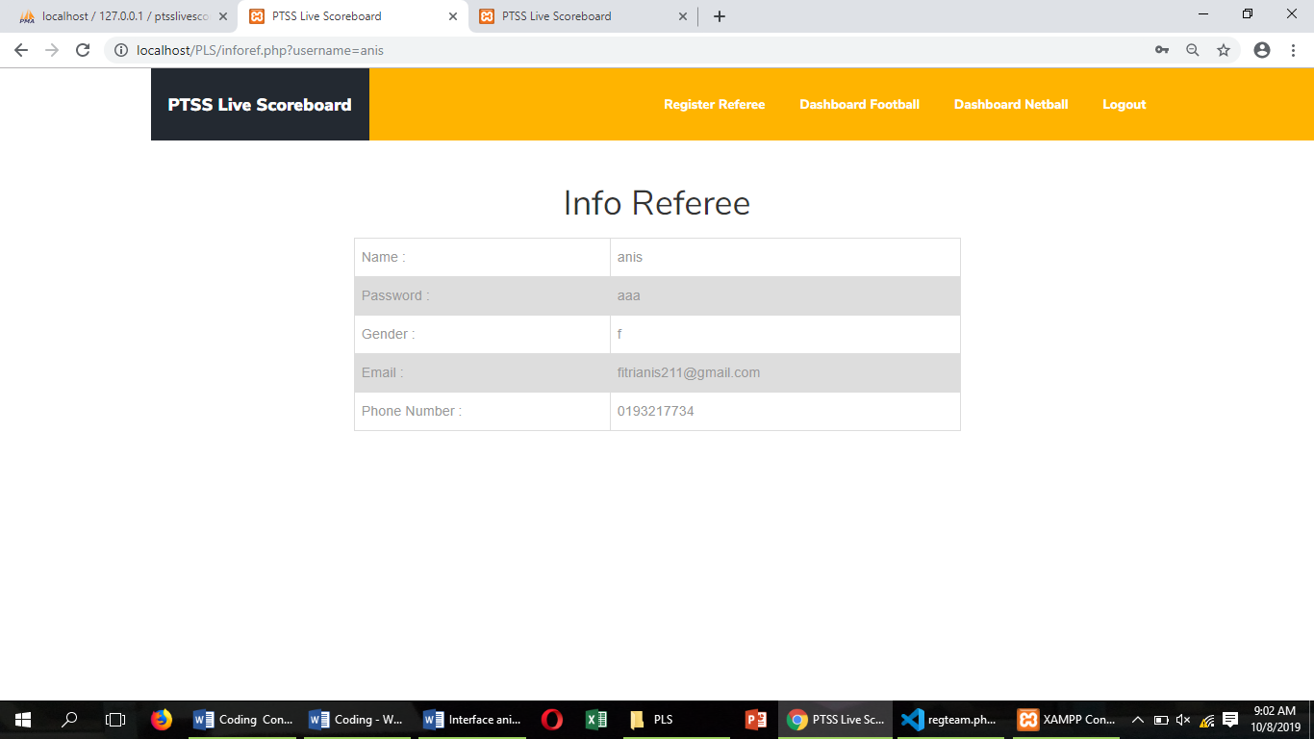

Figure 2.1 6 Interface for info referee

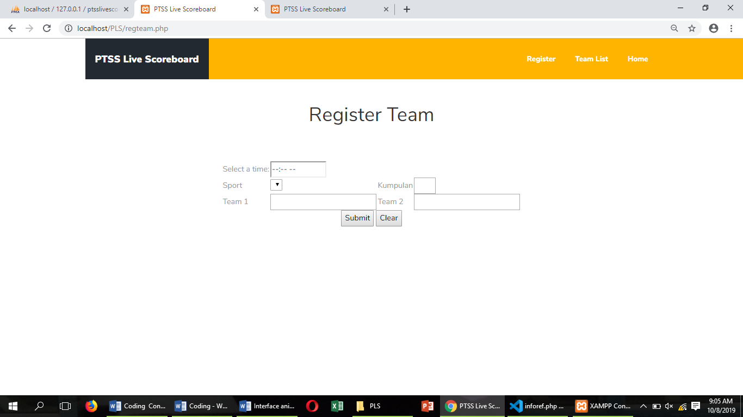

Figure 2.1 7 Interface for register team

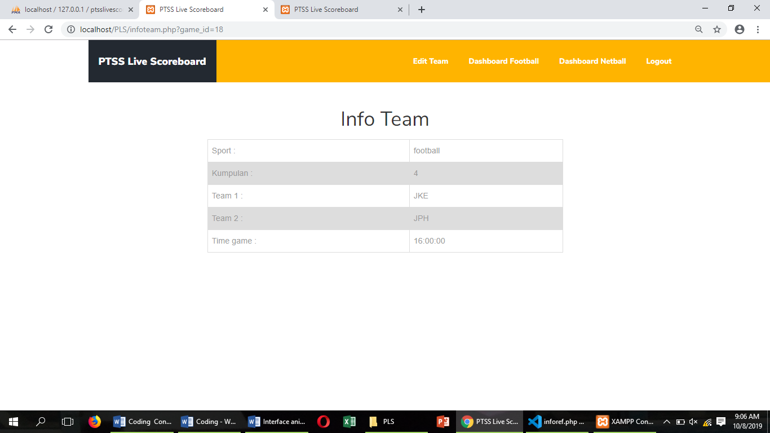

Figure 2.1 8 Interface for info team

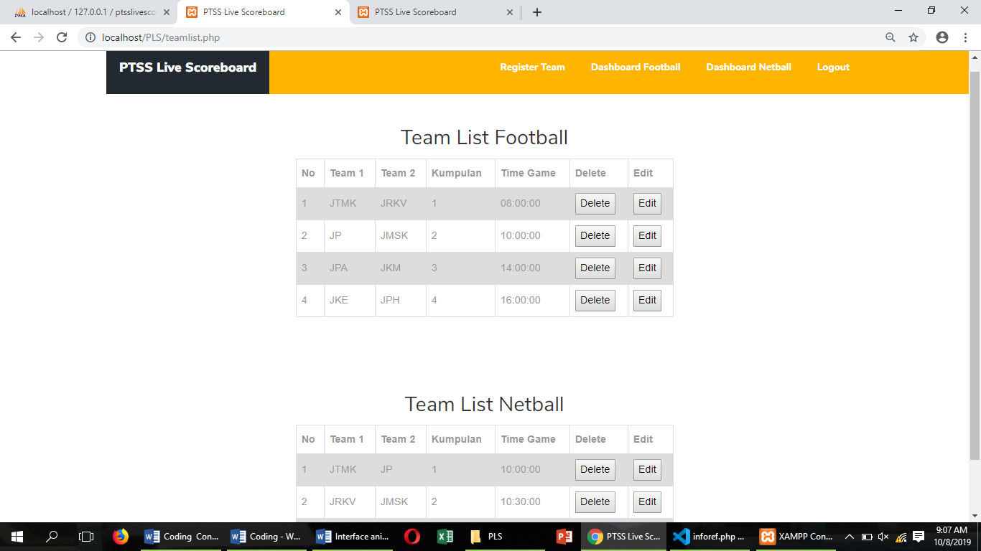

Figure 2.1 9 Interface for team list

This page will be handled by the referee. The referee will decide which set is required to enter the match points.

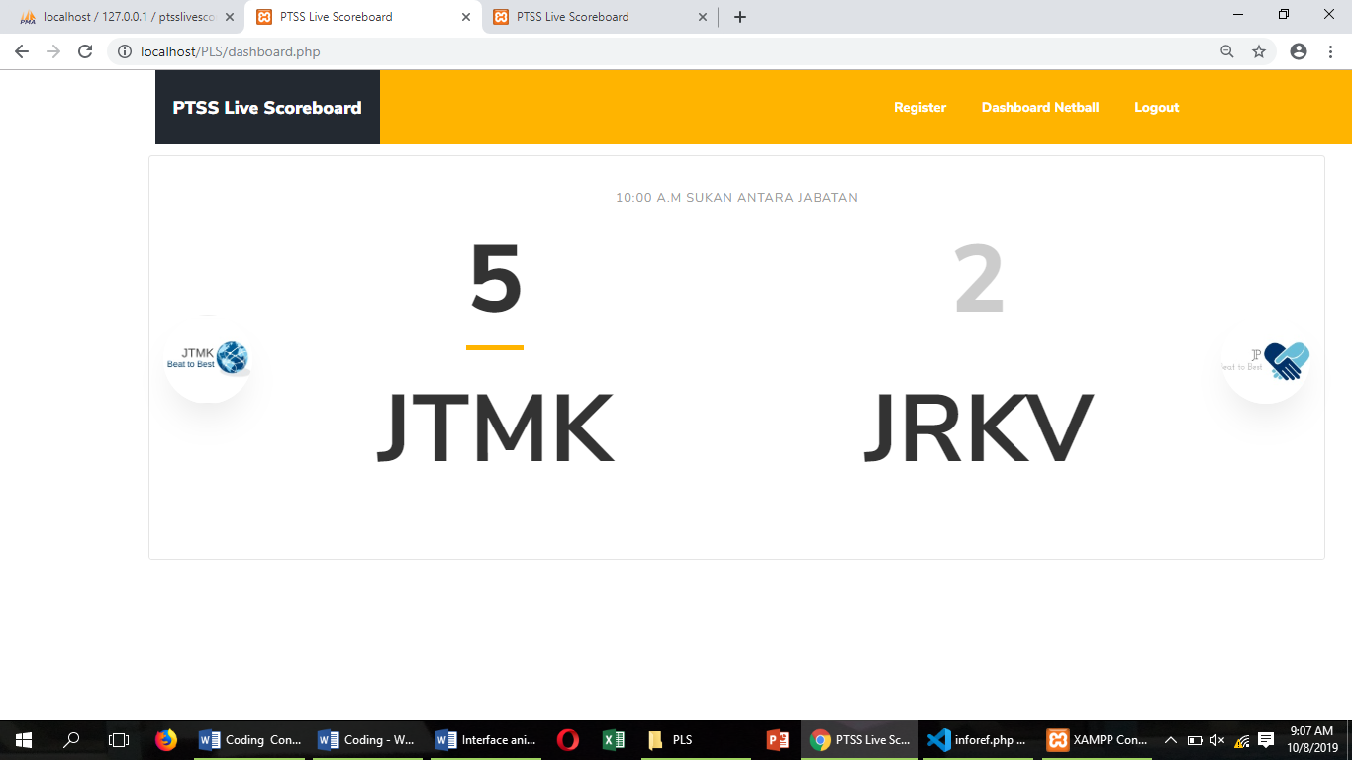

Figure 2.1 10 Interface for dashboard football

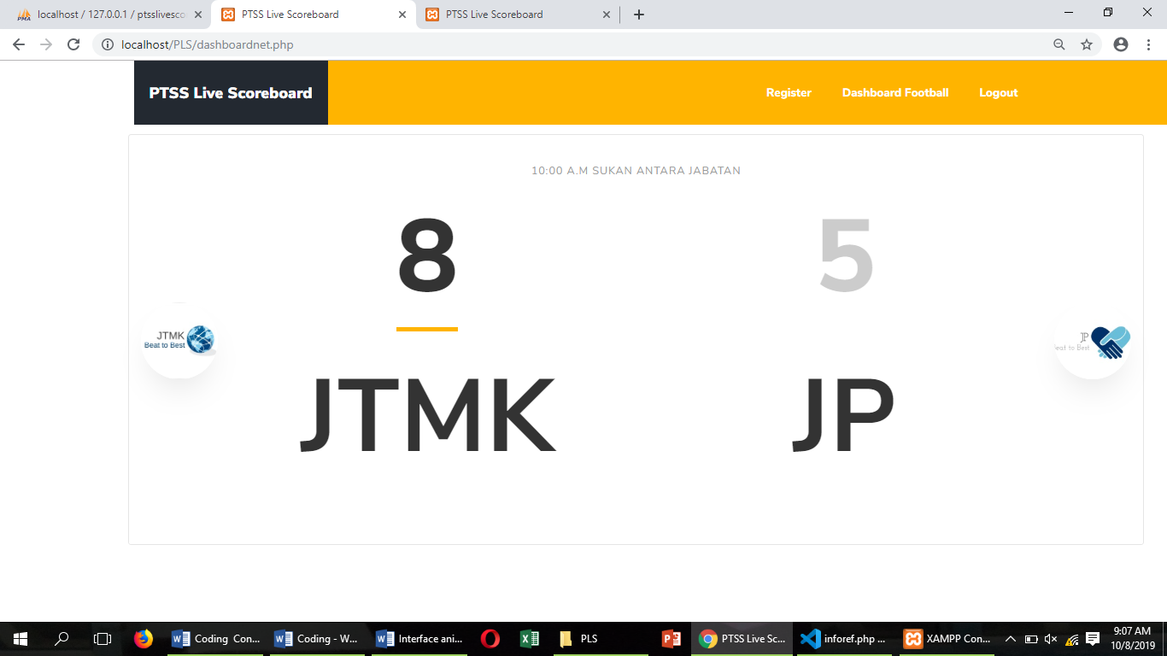

Figure 2.1 11 Interface for dashboard netball

The dashboard page is located in the sports officer section. The sport officer will only be able to view this dashboard on the website and will be displayed on the television screen for viewing. This page will auto refresh every 10 minutes. This dashboard page will show the latest and ongoing matches.

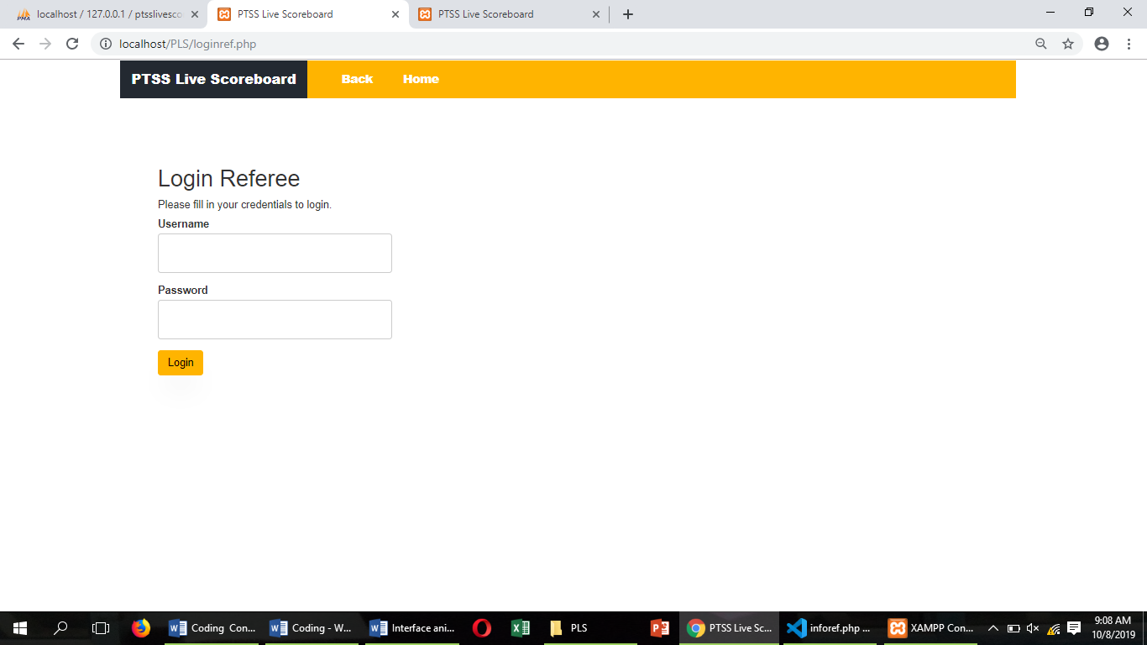

Figure 2.1 12 Interface for login referee

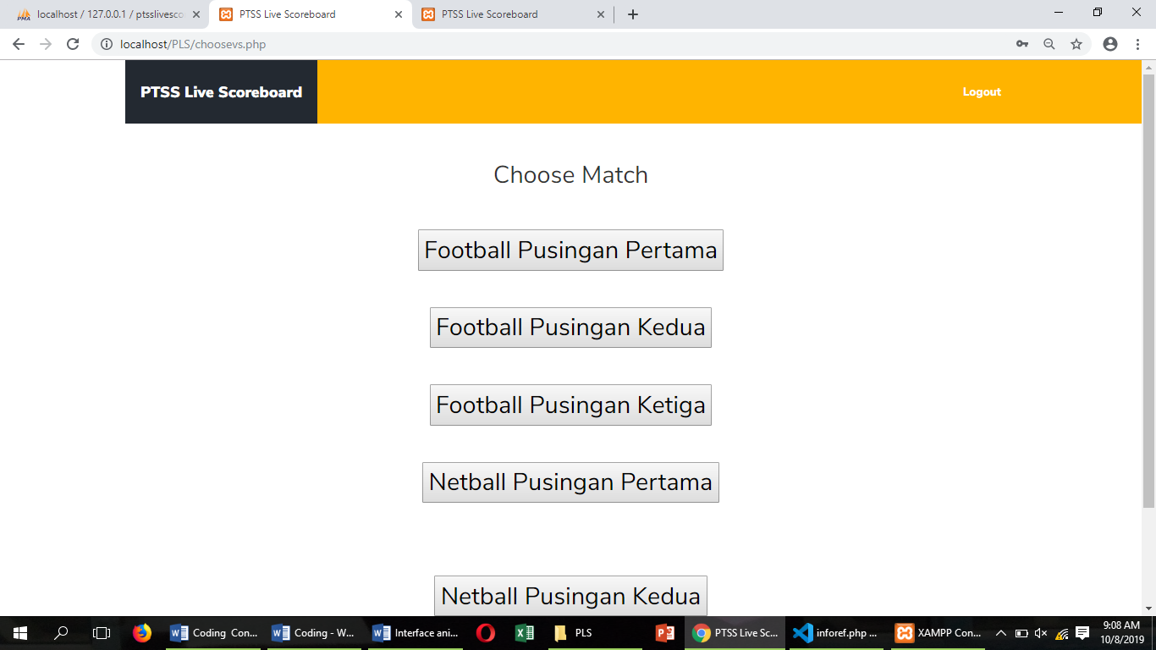

Figure 2.1 13 Interface for choose round game

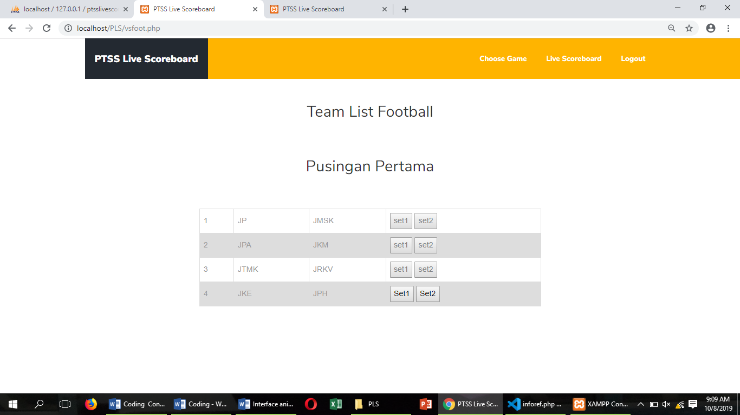

Figure 2.1 14 Interface for choose set in round first

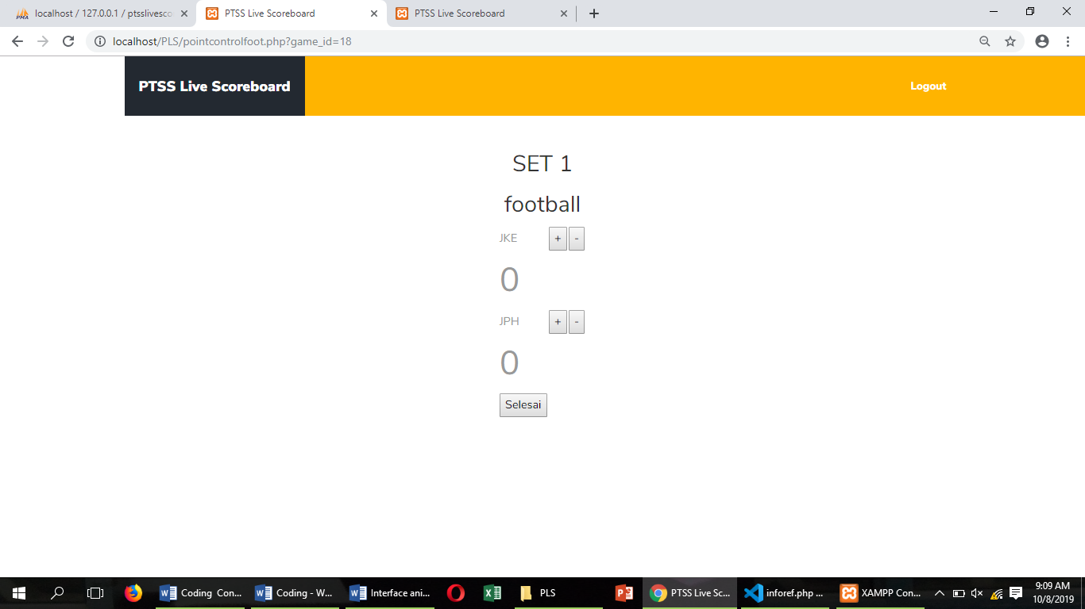

Figure 2.1 15 Interface for key in mark set 1 football

This page will be key in the match point by the referee. After completing set 1, set 2 will also be key in match points. Symbol + to add match points while symbol - to subtract match points. Once done for the key in the match, the referee will need to press the finish button. All match points will be displayed live. All match points are entered into the database.

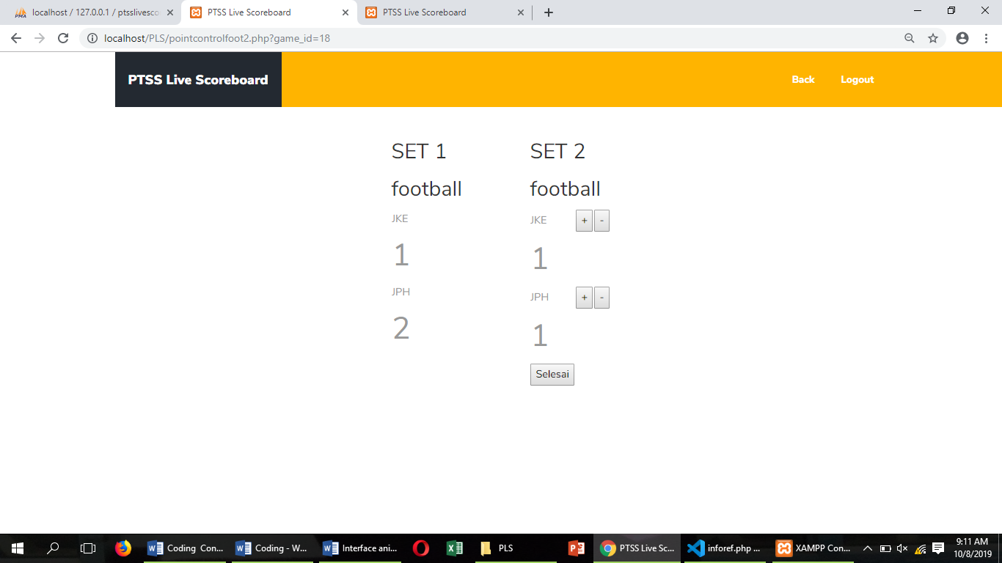

Figure 2.1 16 Interface for key in mark set 2 football

## 2.2: Non-Functional Requirement

* Viewers never allowed to update or edit the score. It was because only a referee have password to go to the point controller page.
* Privacy of information should be audited.

## 2.3: Hardware and Software Requirement

PTSS Live Scoreboard use hardware such as Raspberry Pi 3 Model B, television, wireless router , HDMI Cable, Server, and monitor. Next, this project also need software requirement to integrate the hardware.

|  |  |
| --- | --- |
| **HARDWARE** | **FUNCTIONS** |
| **Raspberry Pi 3 Model B** | * To function as a medium for website to be display on television screen or monitor. |
| **Television/ Monitor** | * To display the live scoreboard for spectators. |
| **Wireless Router** | * To allow it to receive information from server and transmit it to the internet. |
| **Server (Laptop)** | * To use in a network and which provides a service to a client. |
| **HDMI Cable** | * To provide a display of dashboard between Raspberry Pi and television over a single cable |

Table 2.3. 1 Hardware Requirement

|  |  |
| --- | --- |
| **SOFTWARE** | **FUNCTIONS** |
| **Raspbian OS** | Debian-based computer operating system for Raspberry Pi. |
| **Visual Studio Code** | A source-code editor developed by Microsoft for Windows. |
| **Xampp** | Allow website designers and programmers to test their work on their own computers without any access to the Internet. |
| **MySQL** | Used to store anything from a single record of information to an entire inventory of available products for an online store. |

Table 2.3. 2 Software Requirement

## 2.4: System Configuration

System configuration is a term in systems engineering that defines the computer hardware, the processes as well as the various devices that comprise the entire system and its boundaries. This term also refers to the settings or the hardware-software arrangement and how each device and software or process interact with each other based on a system settings file created automatically by the system or defined by the user.

Steps to use the system:

#### **Sport Officer:**

1) Go to Home page. Click on “Login”.

2) Then , choose “Sport Officer”. Filled in information like Username and Password.

3) Click on "Login".

4) Select the "Register Team" menu to register the teams that will compete.

5) If want to to register referee, please click on "Register Referee".

6) For the "Dashboard" menu, the full scoreboard view will be displayed and to view it to the television, please refer to the Raspberry Pi user manual.

**Referee:**

1) Go to Home page. Click on “Login”.

2) Then , choose “Referee”. Filled in information like Username and Password.

3) Click on "Login".

4) Select the “Point Controller” menu, then choose the sport that they will be judge such as Netball or Football.

5) Click on + to add point or – to remove a point.

**Viewers:**

1) Go to Home page. Viewers can see the score for current game.

2) Click on About menu, viewers can see information about the web developers.

3) If the viewers want to see the match schedule , click on it and it will be appear a knockout schedule.

4) For All Result menu, there will be a full result after the match is done.

### **2.4.1: System configuration for Raspberry Pi**

#### i)Display Raspberry Pi to the Television.

1. Turn on the Raspberry Pi 3 Model B by connected the power supply with on/off switch button cable.

2. Open Xampp software on the server and click Start on Apache and MySQL.

3. Connect the HDMI Cable between Raspberry Pi and Television or monitor.

4. After Raspberry Pi turned on, go to the File Manager. Right click on folder LCD_show_v6_1_3.

5. Select Open In Terminal.

6. Type sudo ./LCD_hdmi in Terminal.

7. At server, go to CMD(Command Prompt) and type ipconfig to get the IP Address.

8. Back to Raspberry Pi, select Browser.

9. Insert the IP Address of the server and slash with index.php.

Example: 10.68.8.51/index.php

#### ii) Turn off the screen display on Television.

1. Go to the File Manager. Right click on folder LCD_show_v6_1_3.

2. Select Open In Terminal.

3. Type sudo ./LCD_hdmi in Terminal. Type the command:

pi@raspberrpi:~/LCD_show_v6_1_3 $ cd LCD_show_v6_1_3

pi@raspberrpi:~/LCD_show_v6_1_3 $ sudo chmod 777./*

pi@raspberrpi:~/LCD_show_v6_1_3 $ sudo ./LCD35_v

4. The television screen will blank and Raspberry Pi display it screen.

5. Shut down the Raspberry Pi and the Television.

### **2.4.2 System Configuration for Web System**

Match schedule

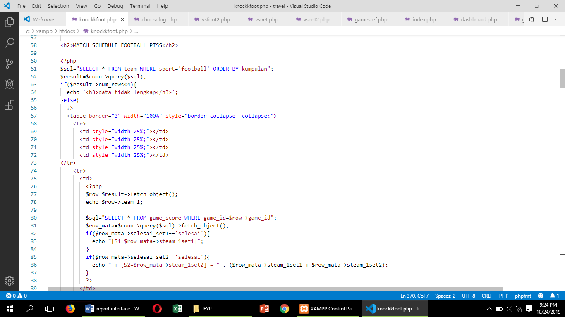

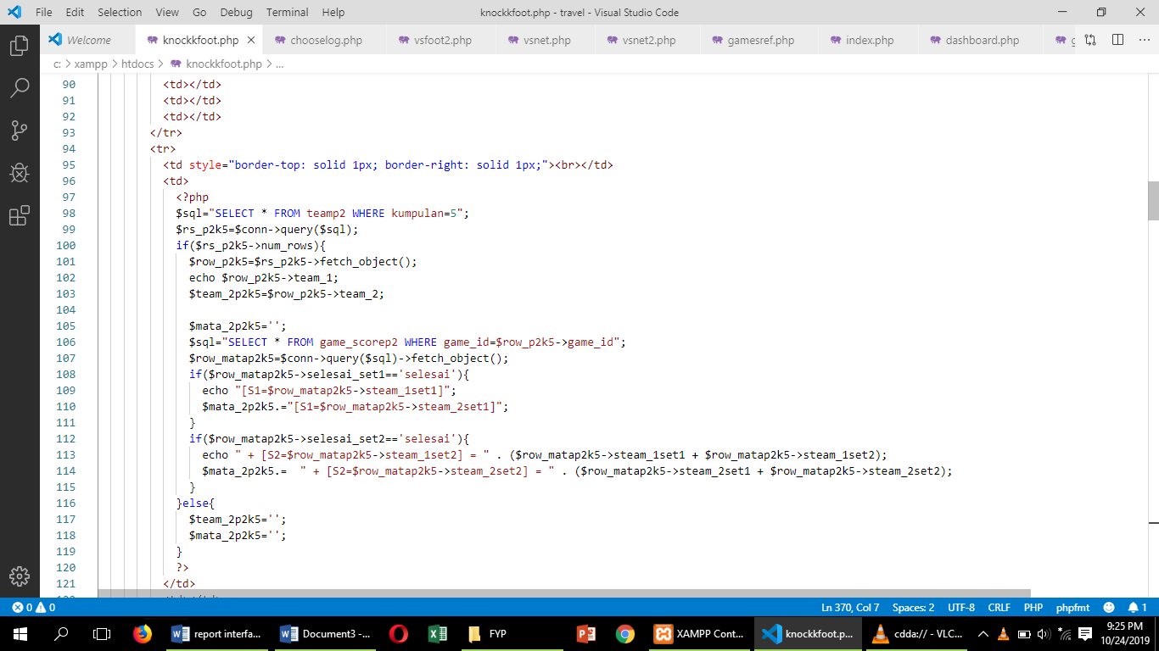

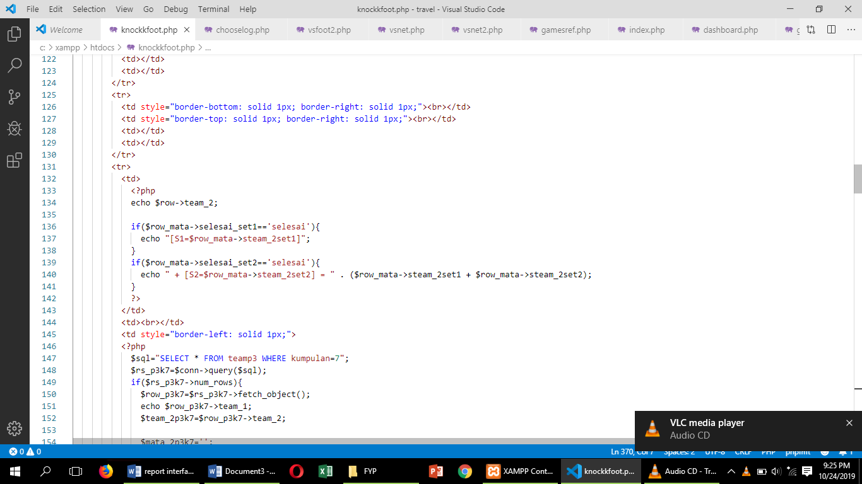

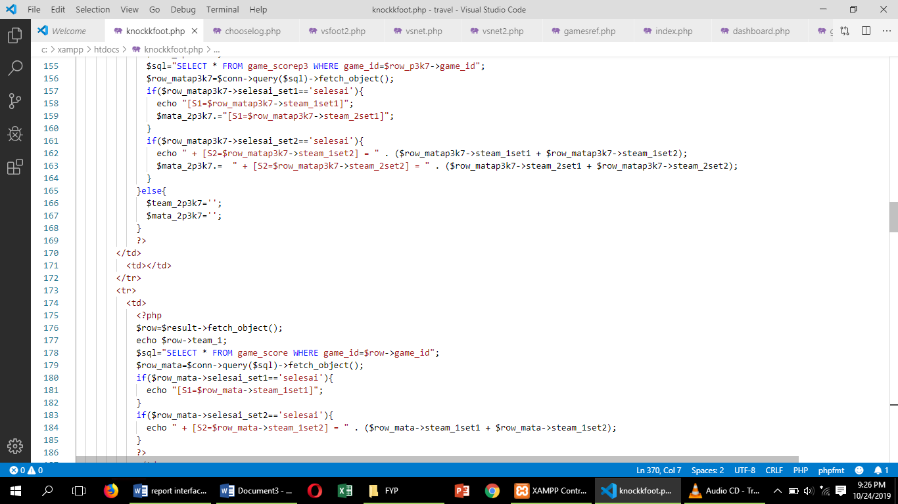

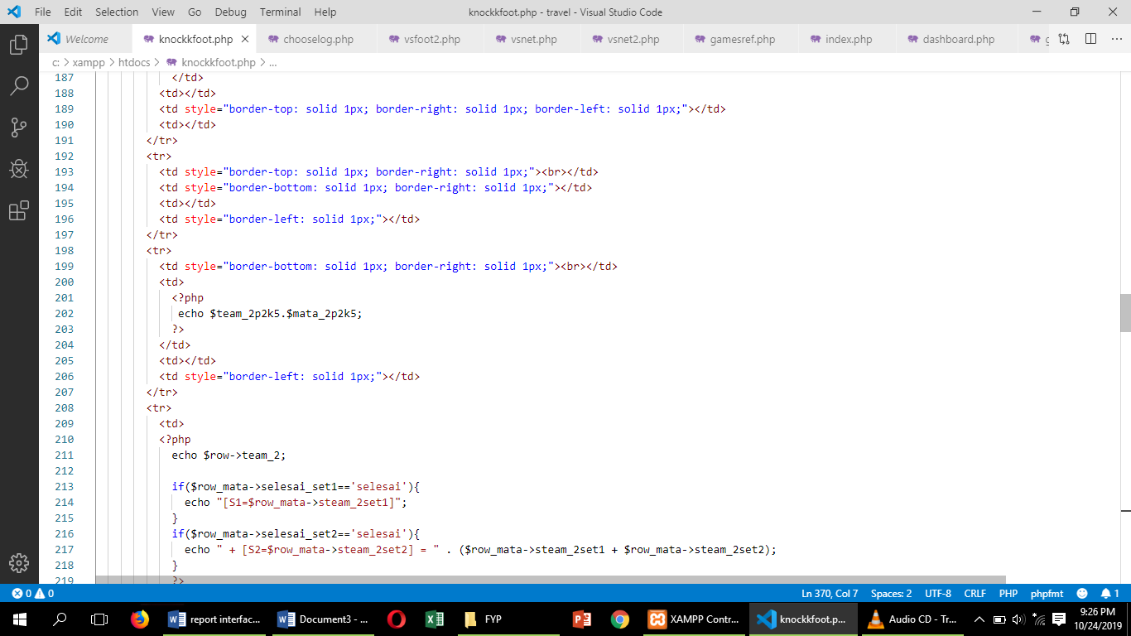

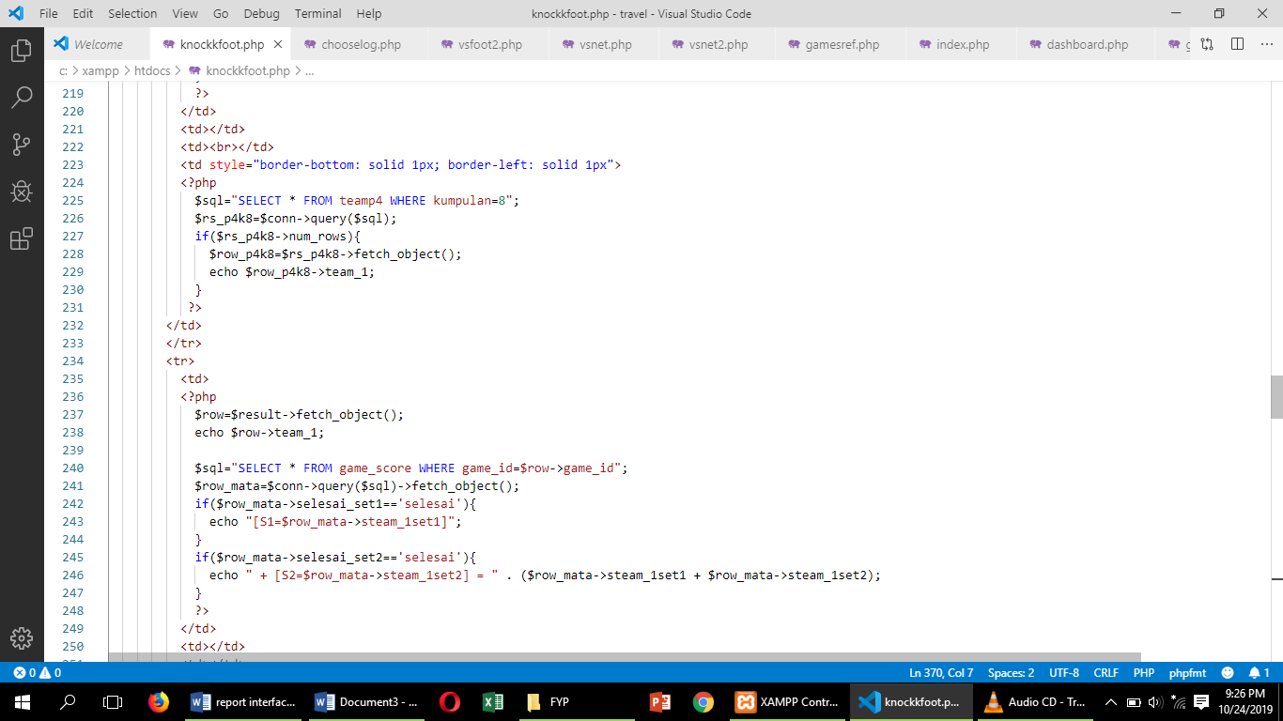

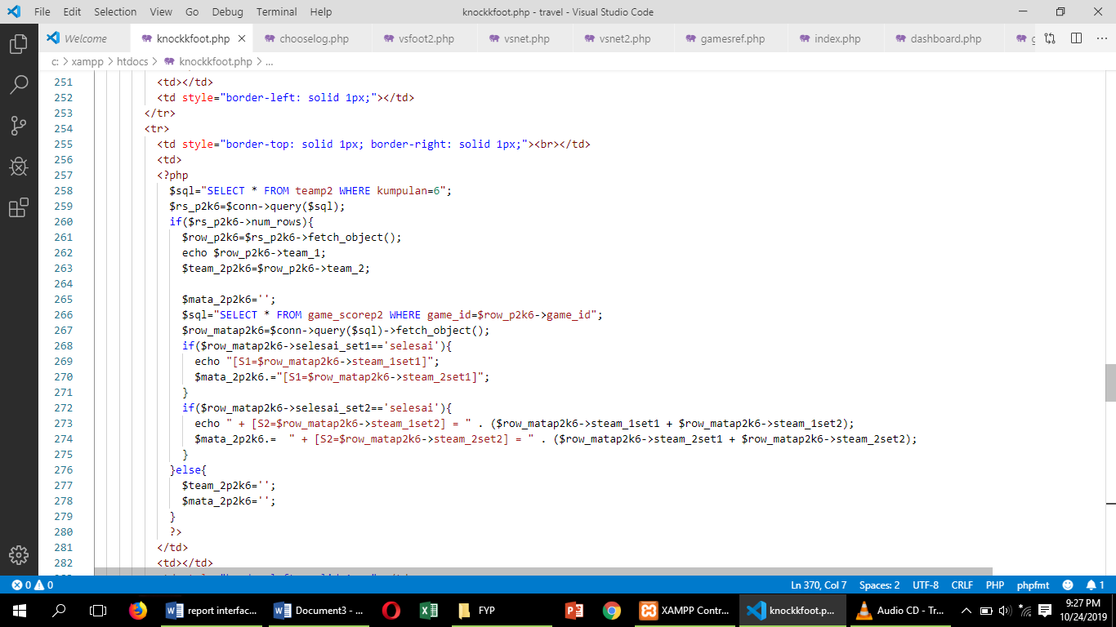

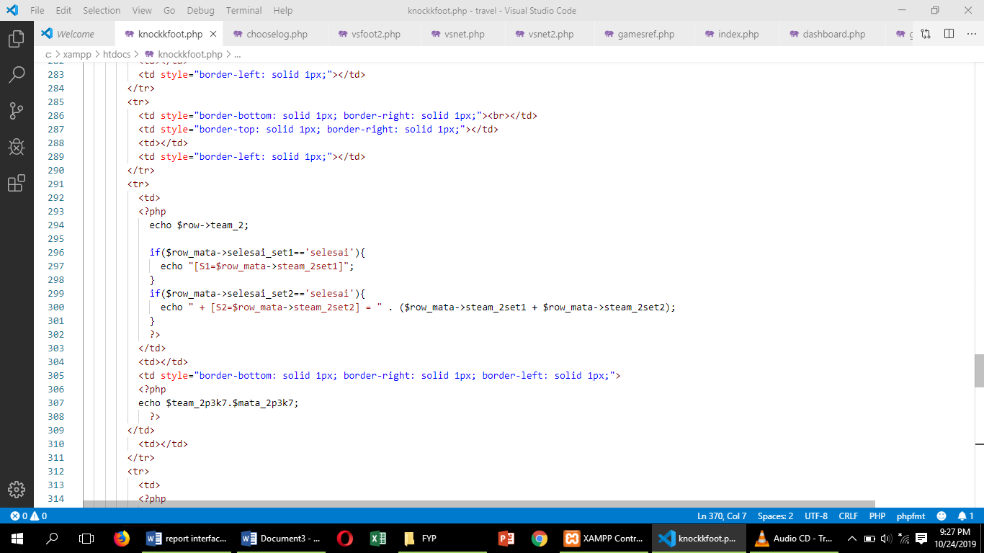

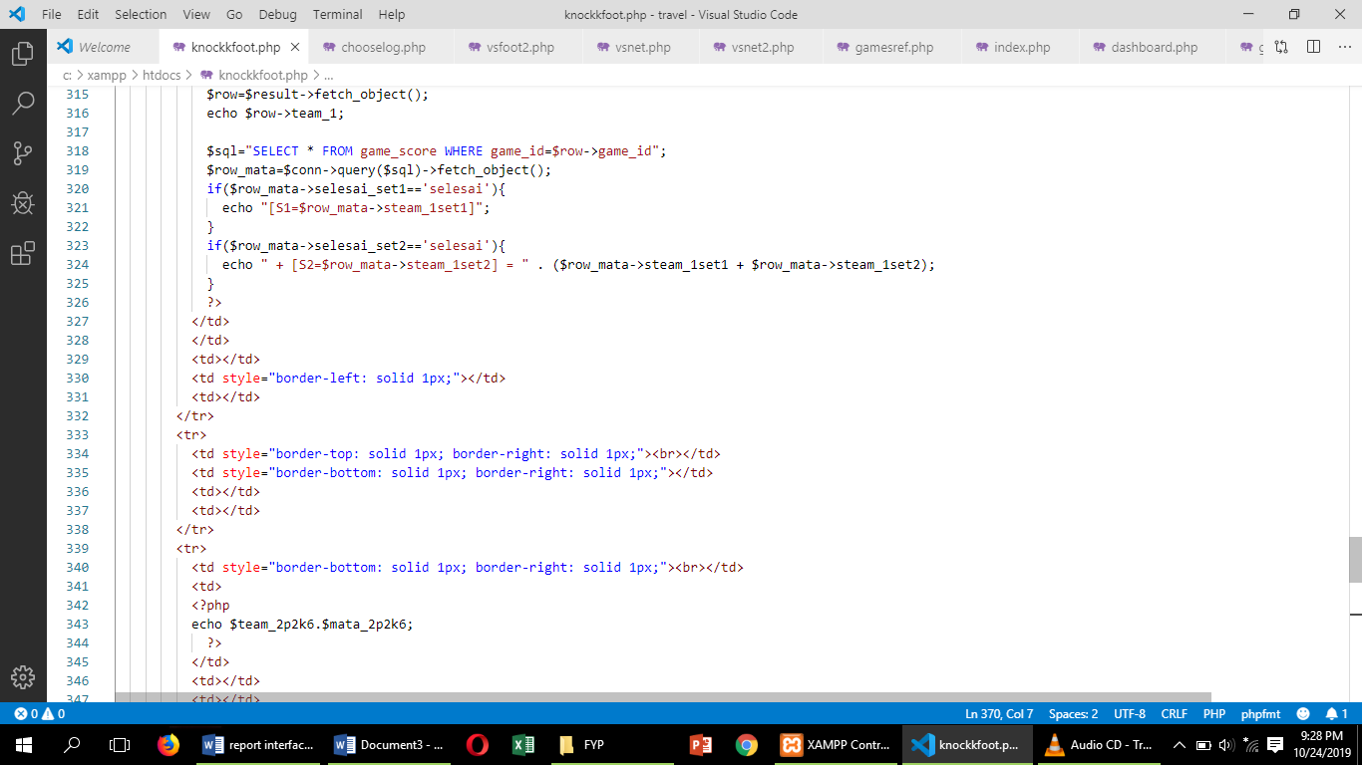

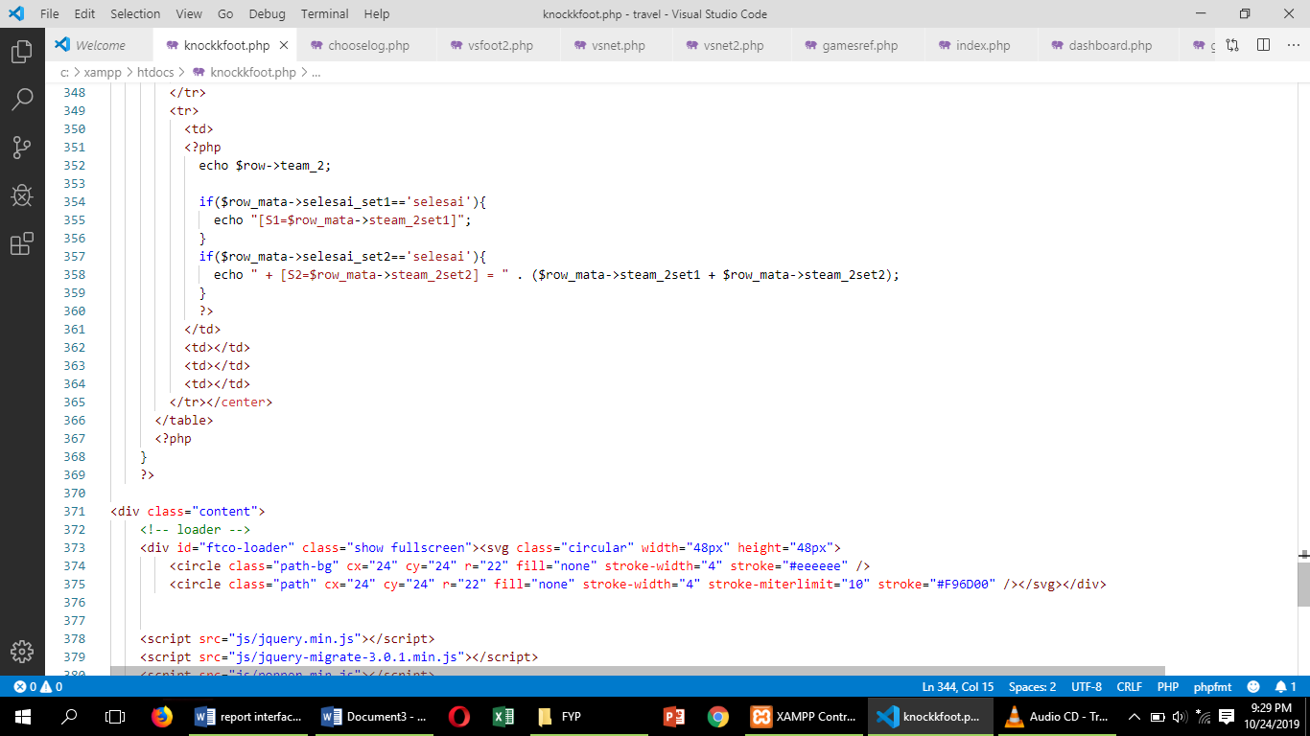

Choose login

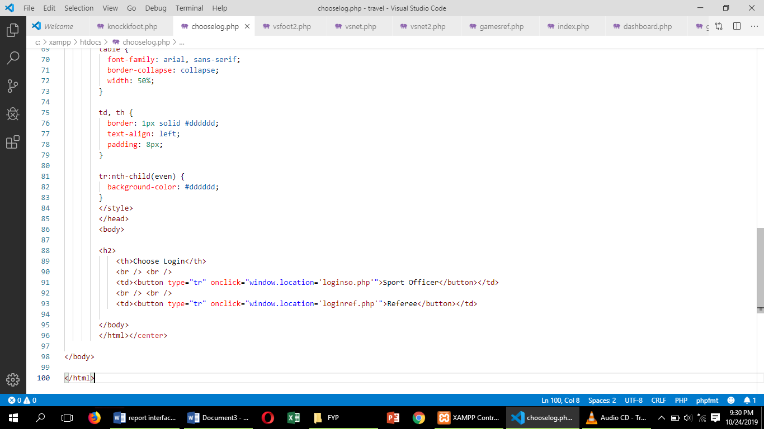

Register referee

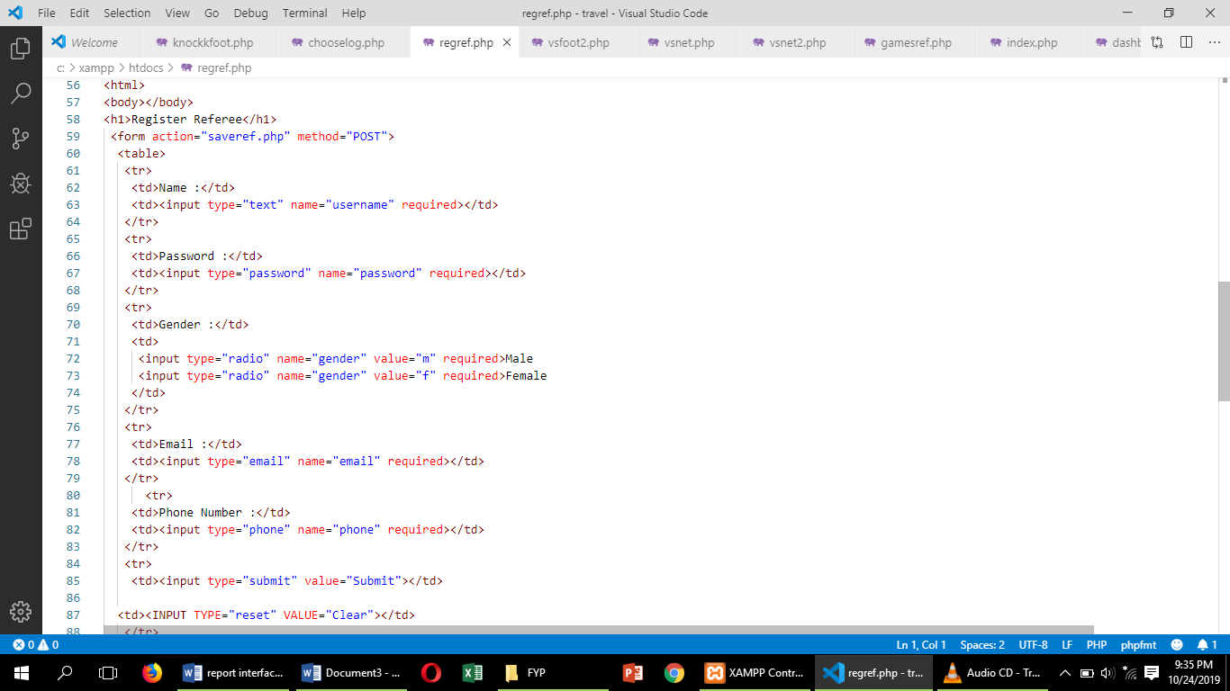

Register team

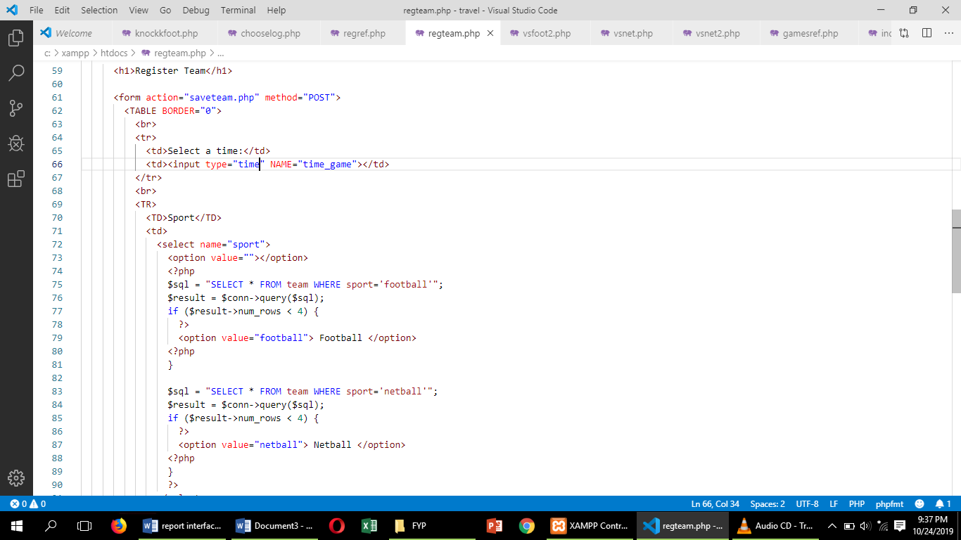

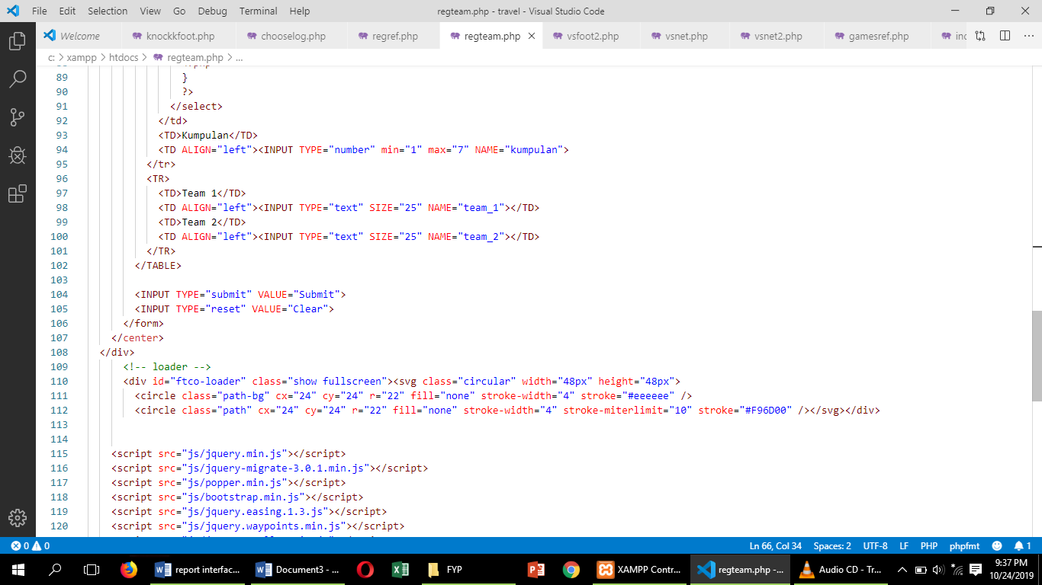

Dashboard

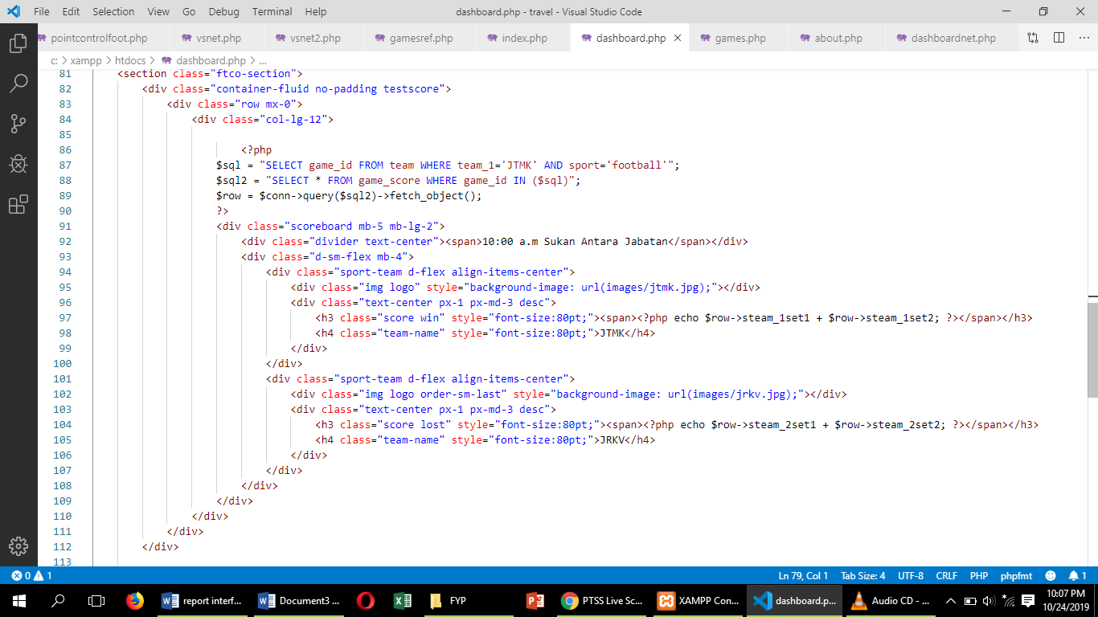

Livescoreboard

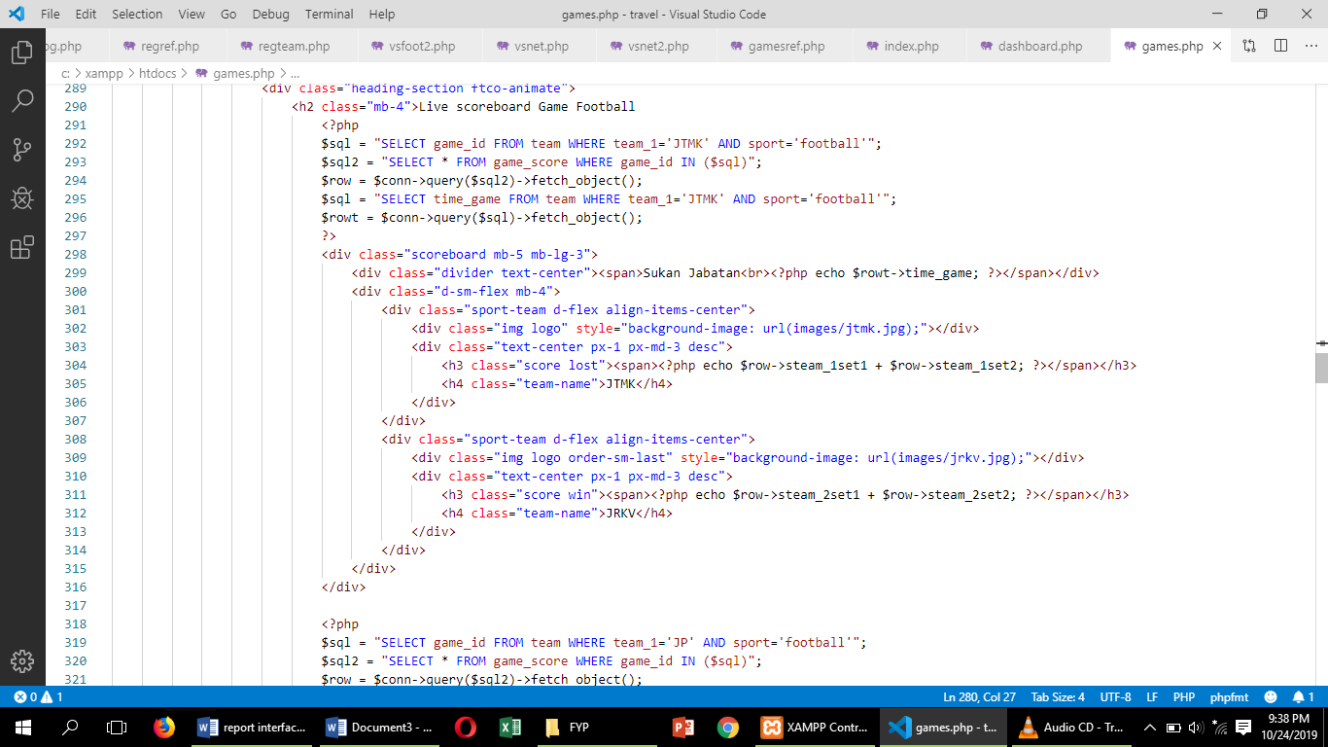

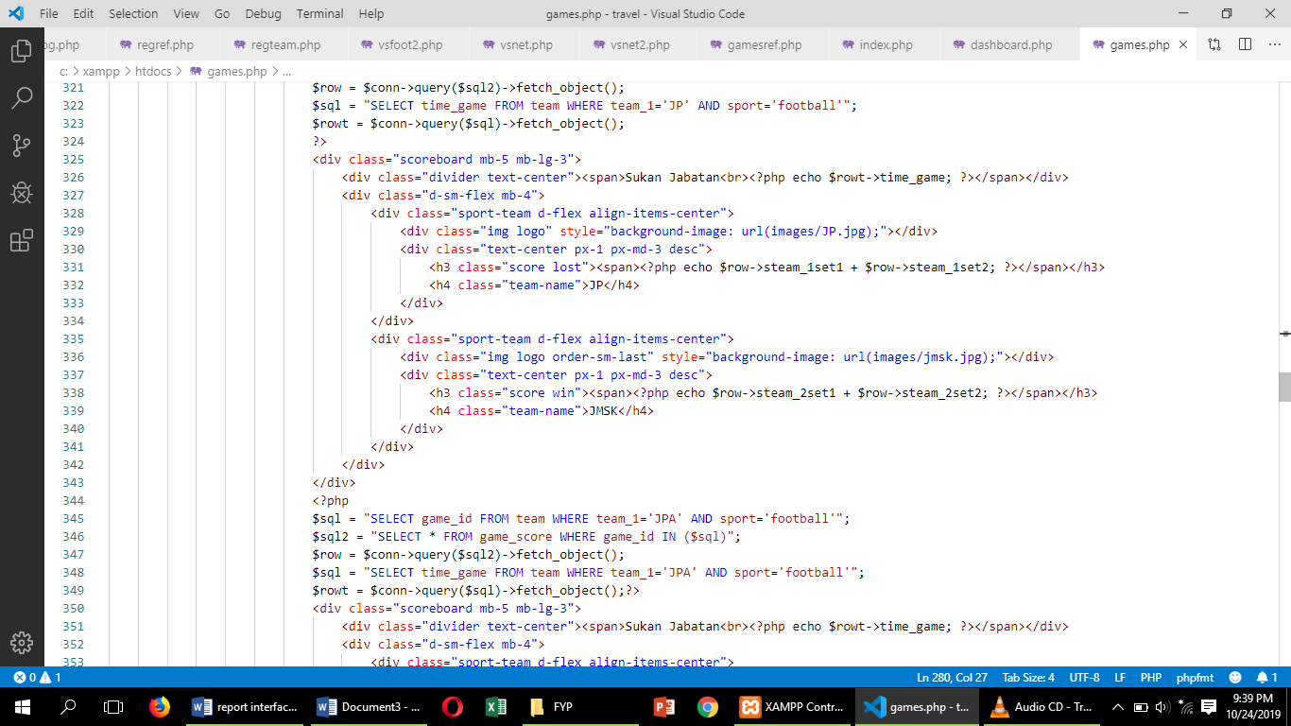

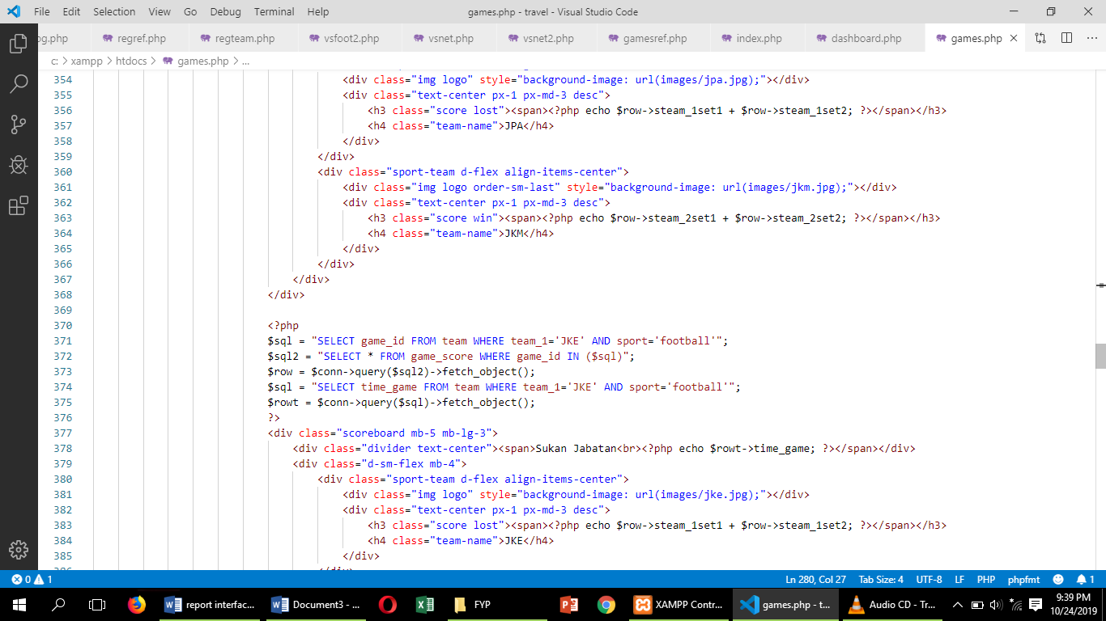

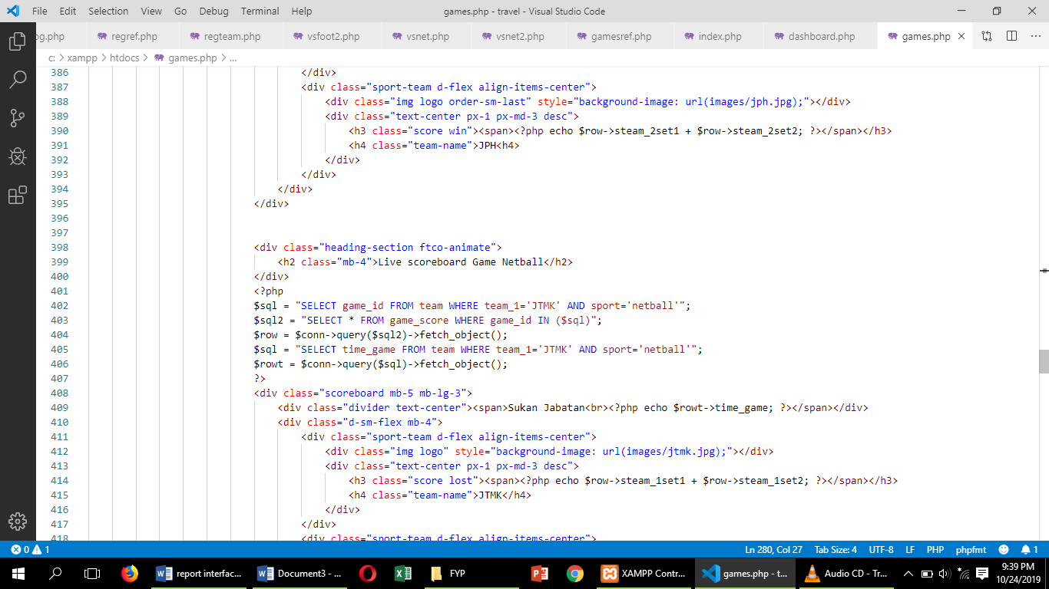

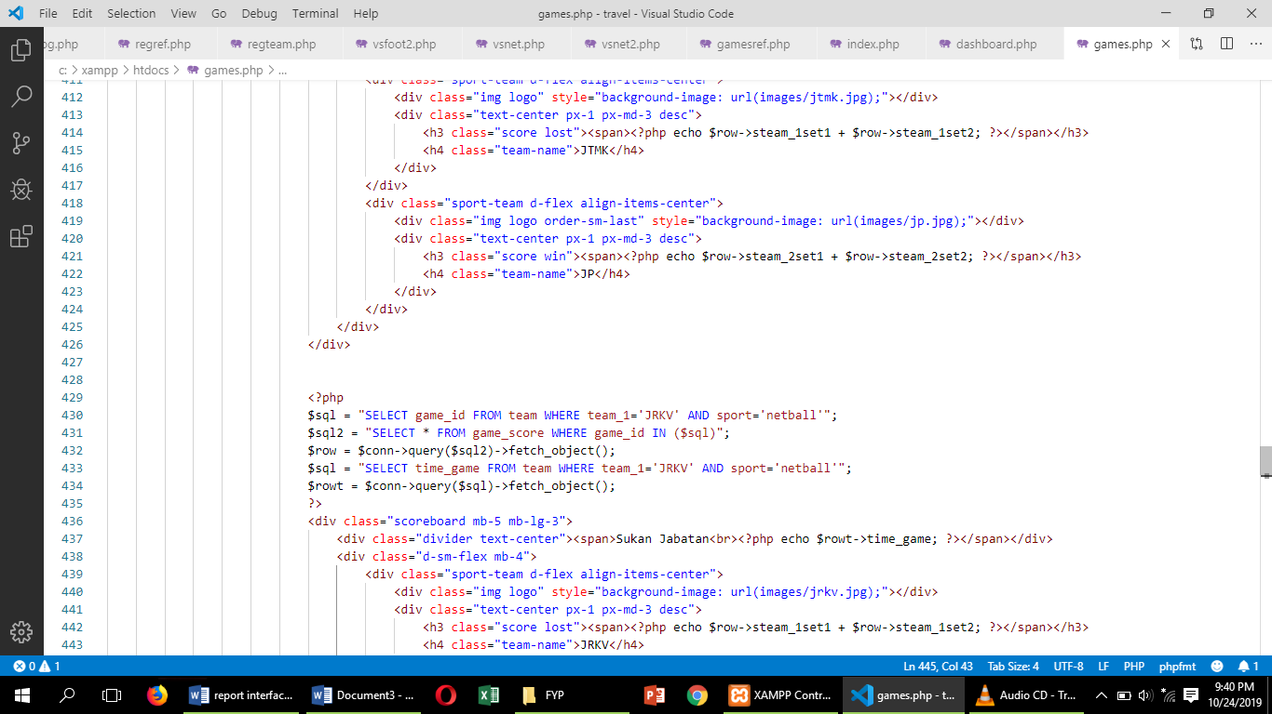

Set

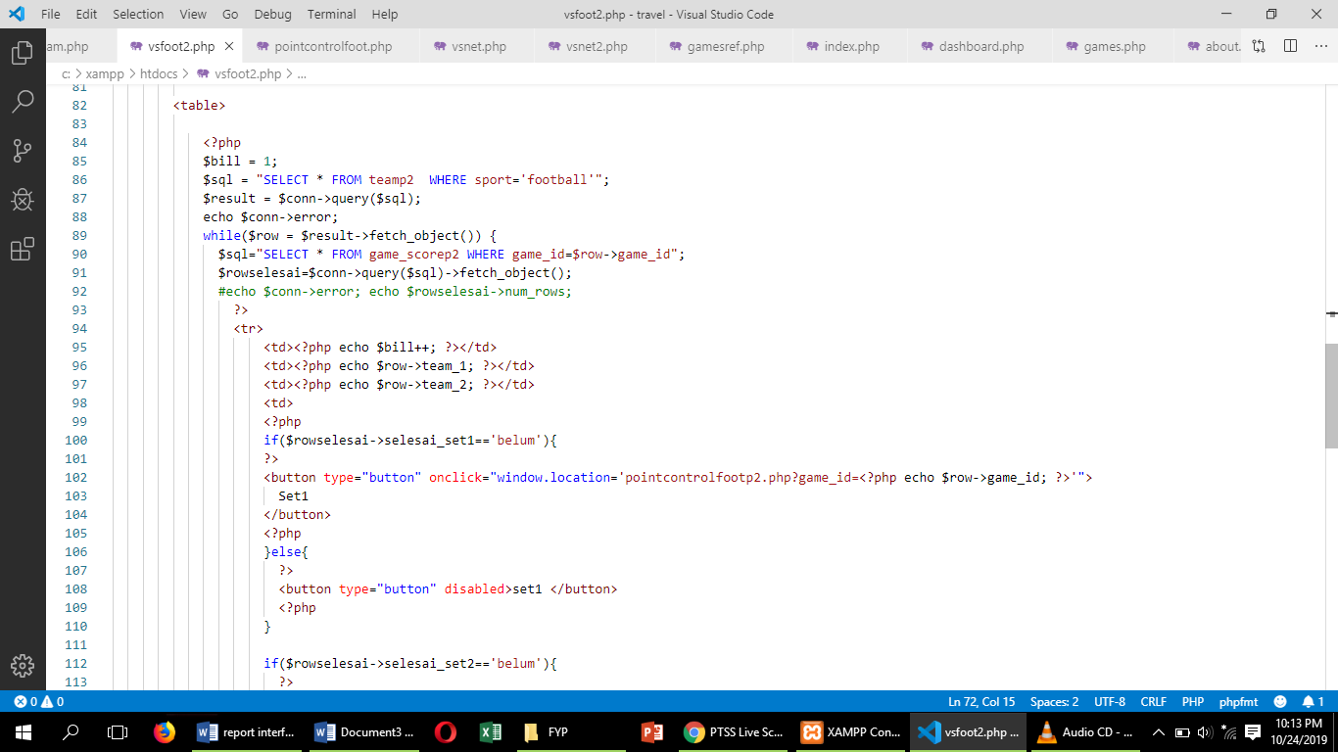

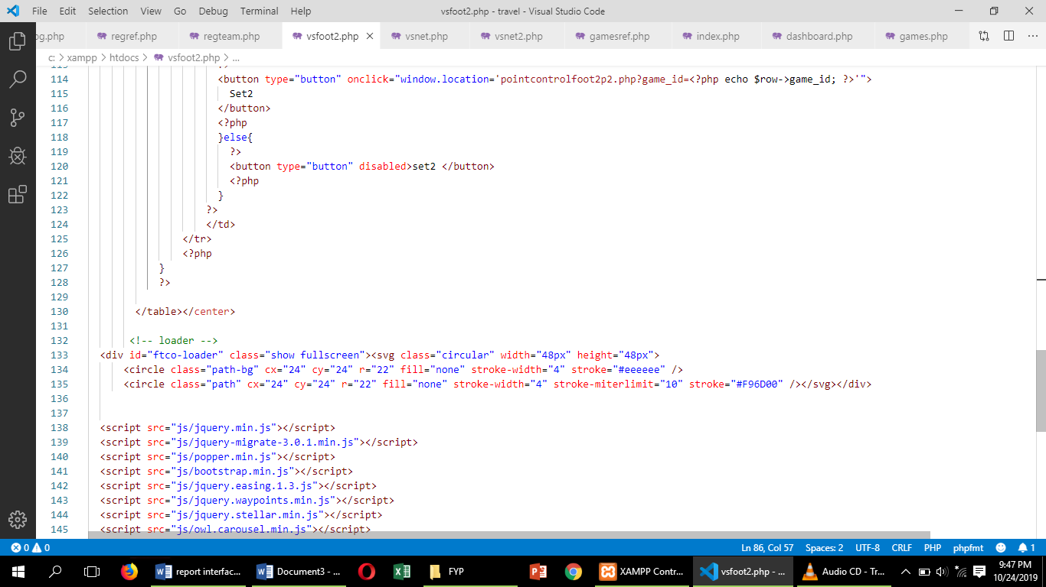

Key in mark

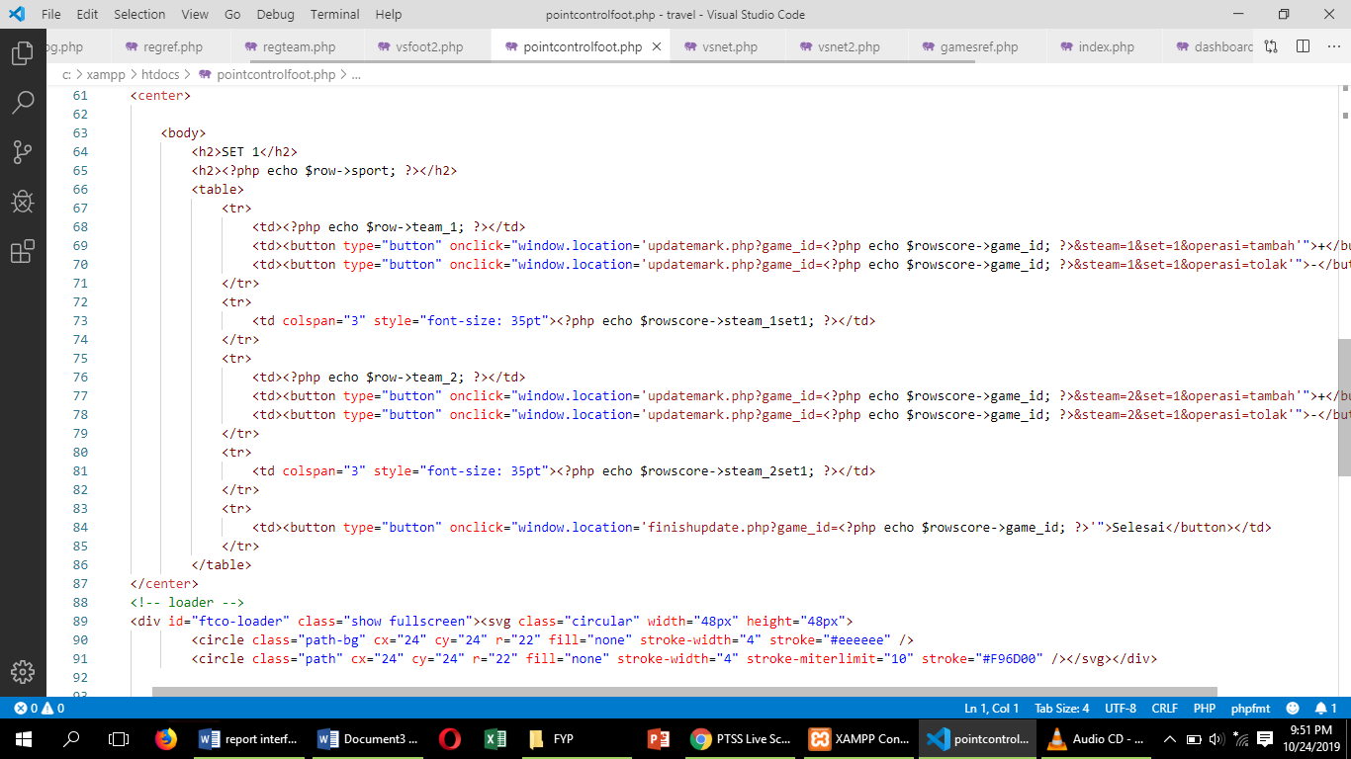

Home

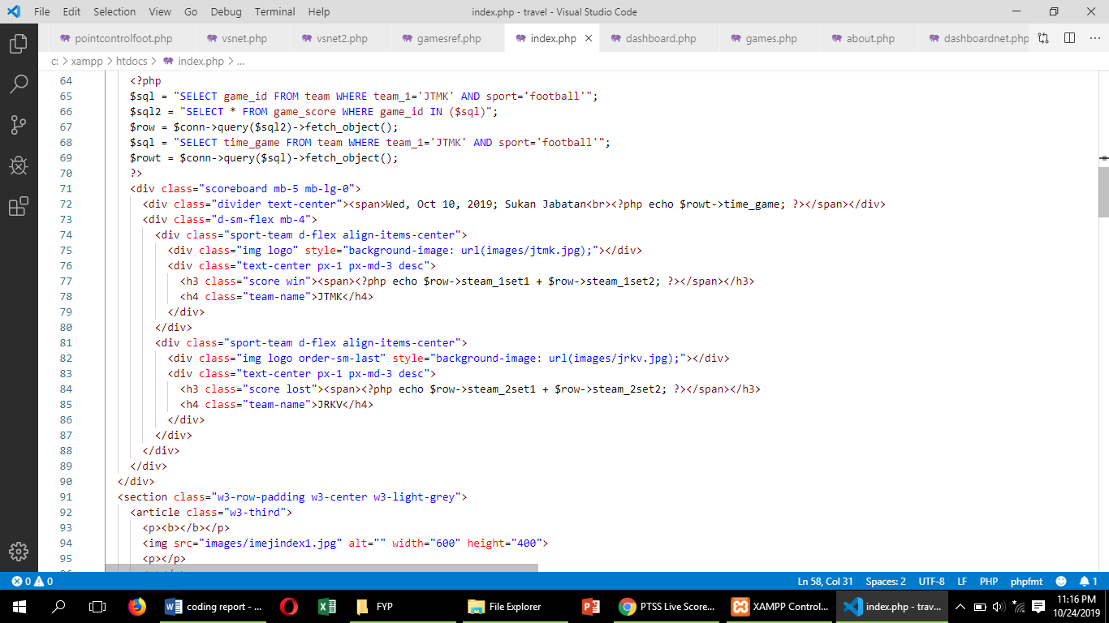

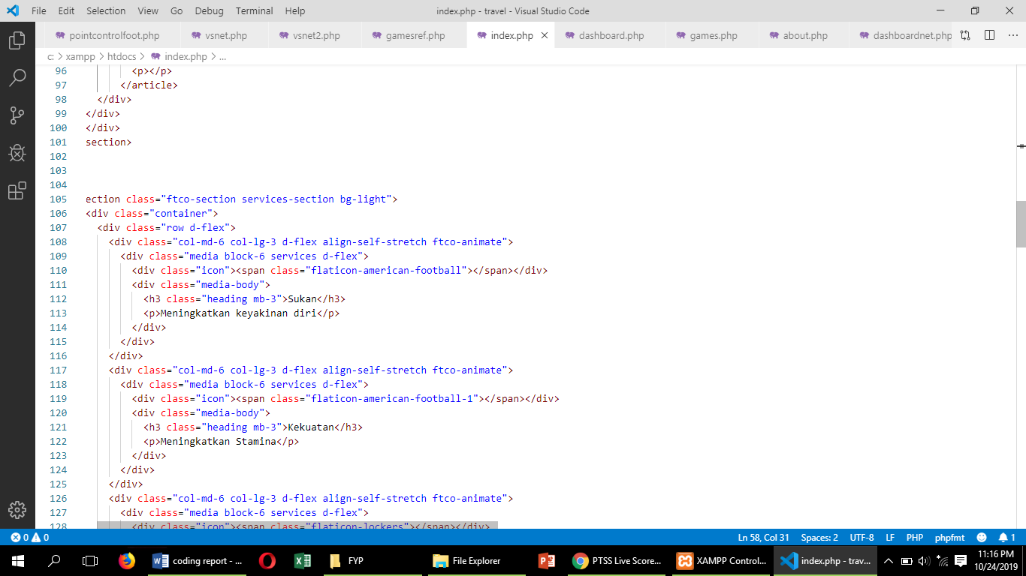

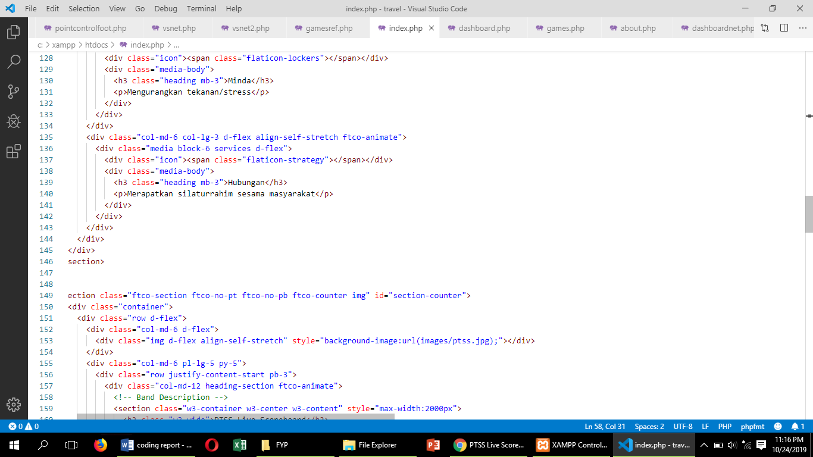

About

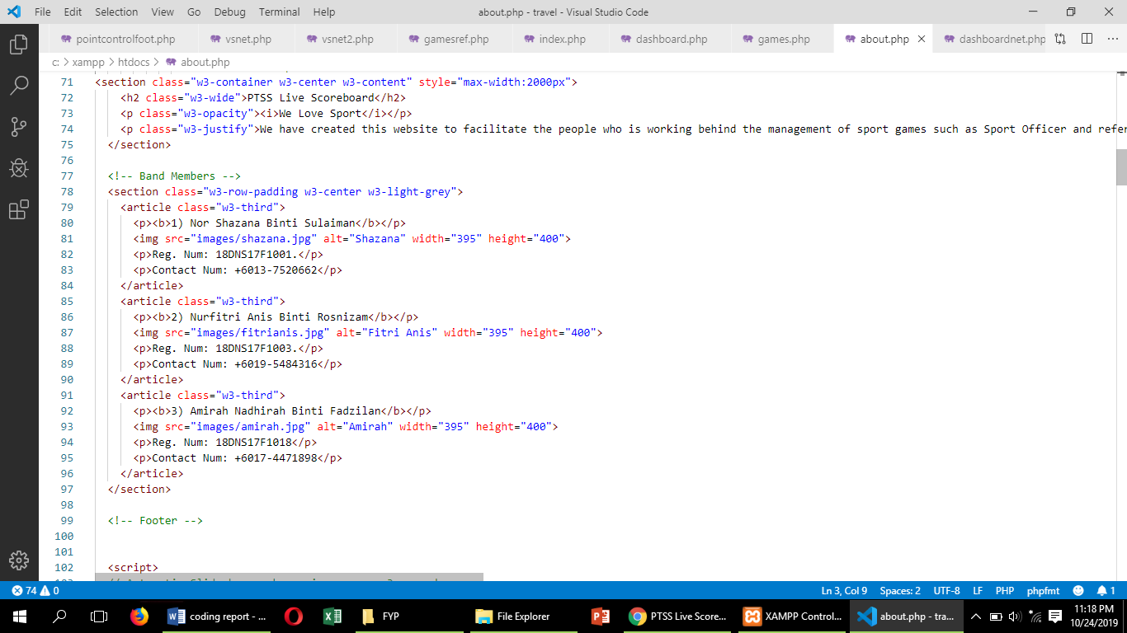

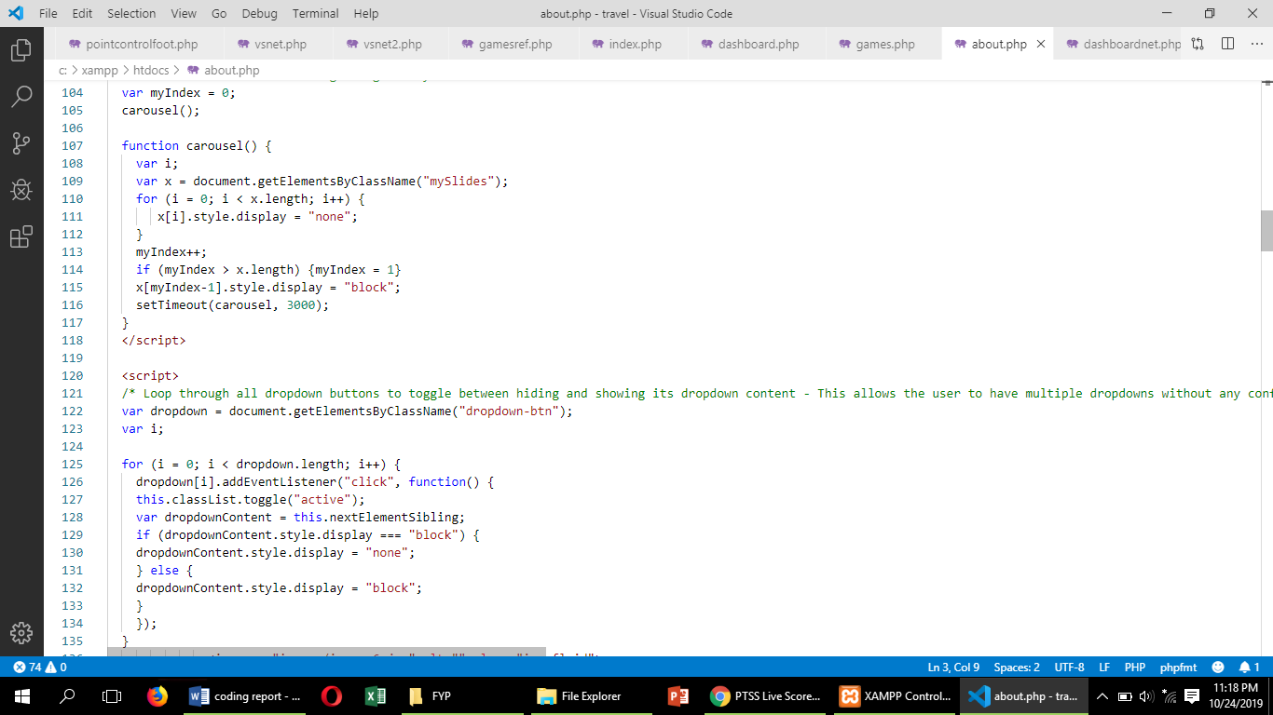

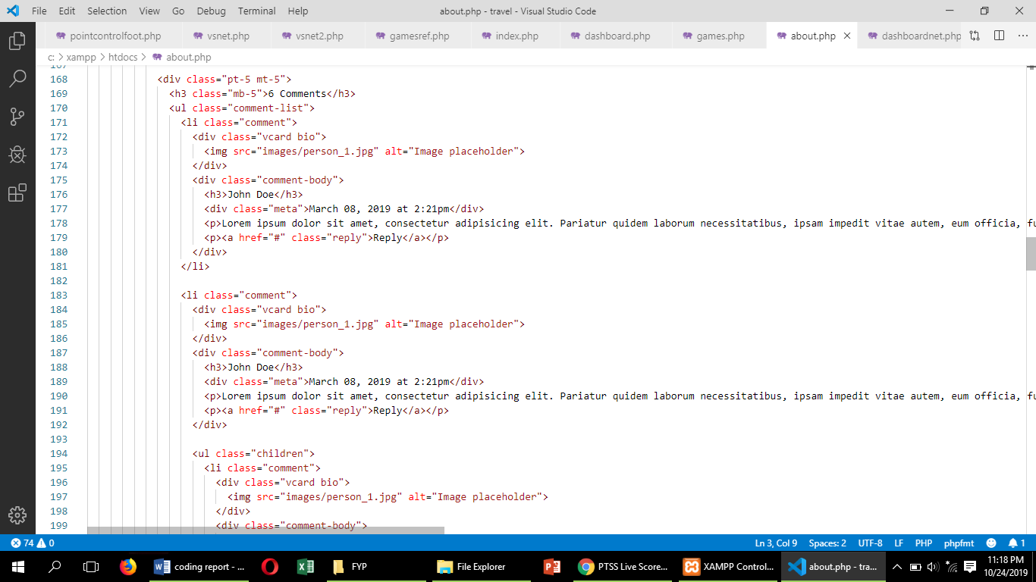

# CHAPTER 3

# FINAL DESIGN

In this chapter, there are several sub-chapter that is logical design and physical design. In the sub-chapter logical design, we have used the flow chart and functional decomposition diagram. In addition, PTSS Live Scoreboard physical design is to design website interface using Visual Studio Code.

## 3.1 Logical Design

A logical design is a conceptual, abstract design. The process of logical design involves arranging data into a series of logical relationships called entities and attributes. An entity represents a chunk of information. In relational databases, an entity often maps to a table. An attribute is a component of an entity and helps define the uniqueness of the entity. In relational databases, an attribute maps to a column.

### 3.1.1 Flow Chart

Enter link url

ptsslivescoreboard

First time login

Yes

Login the website

Yes

Yes

Main user interface

Yes

Choose login

Yes

Sport Ofiicer

Referee

Point control

Register referee and team

No

Live Scoreboard

Key-in points

### 3.1.2 Functional Decomposition Diagram (FDD)



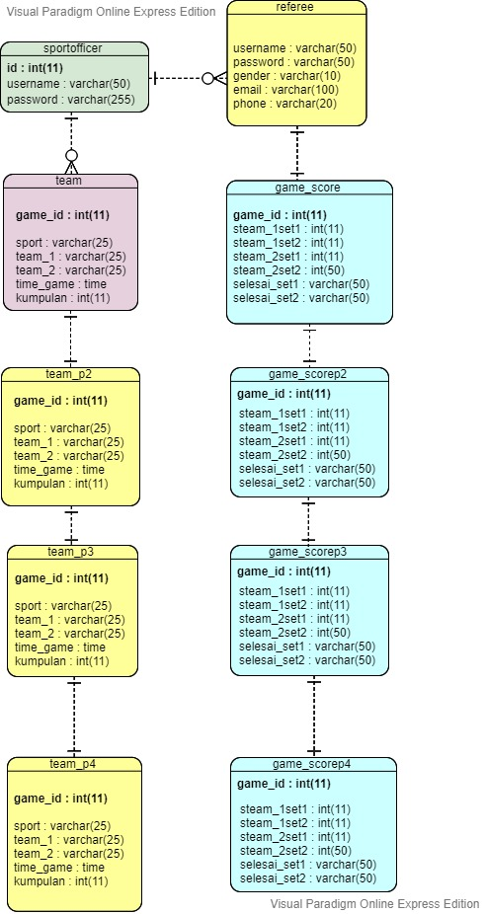

Figure 3.2. 1 This is ERD for PTSS Live Scoreboard.

## 3.2 Physical Design

The physical design is a kind of system design. It is a graphical illustration of the system, representing external and internal entities of the system with to and from data flow.

An external entity is an entity exterior to the system and internal entity is a entity inside the system where both can convert the data.



Figure 3.2. 2 Main interface of PTSS Live

.



Figure 3.2. 3 Interface for 'About' page.

This is the main page for PTSS Live Scoreboard. This page could be access by everyone and there are several menu to be choose which is Home, About, Match Schedule, All Result, Live Scoreboard and Login.

'Home' on the menu is the first page everyone will see. This page contains recent sports scores. While the 'About' page contains information such as the developer of the web site. In addition, this page also tells the background of the system. The 'All Result' page will tell visitors the overall score for the match that has taken place. In addition, the 'Match Schedule' page will display the match schedule for the upcoming game. In the meantime, there is also a 'Live Scoreboard' page where it will show the match points. Finally, there is a selection button on the menu that is 'Login'. Only sport officer and referees will choose the menu.



Figure 3.2. 4 Interface match schedule football



Figure 3.2. 5 Interface match schedule netball



Figure 3.2. 6 Interface for Livescoreboard



Figure 3.2. 7 Interface choose login



Figure 3.2. 8 Interface login sport officer



Figure 3.2. 9 Interface for sport officer



Figure 3.2. 10 Interface for register referee



Figure 3.2. 11 Interface for info referee



Figure 3.2. 12 Interface for register team



Figure 3.2. 13 Interface for info team



Figure 3.2. 14 Interface for team list



Figure 3.2. 15 Interface for dashboard football



Figure 3.2. 16 Interface for dashboard netball



Figure 3.2. 17 Interface for login referee



Figure 3.2. 18 Interface for choose round game



Figure 3.2. 19 Interface for choose set in round first



Figure 3.2. 20 Interface for key in mark set 1 football



Figure 3.2. 21 Interface for key in mark set 2 football

# CHAPTER 4

# Test Description and Results

This project consists of Unit testing and Integrated testing in the phase of testing the website system. The system was tested for the signup, login, menu, register team and referee and also the point controller.

## 4.1 Unit Testing Plan

**WEBSITE SYSTEM USER UNIT TESTING PLAN (UTP)**

|  |  |  |  |  |
| --- | --- | --- | --- | --- |
| **No** | **Test Case**  **Name** | **Test Procedure** | **Pre-condition** | **Result (Pass/Failure)** |
| 1. | Login | User is required to fill the username and password field before access the system | User need to signup before login | Pass |
| 2. | Home | User need to choose any options that they prefer | User required to go to PTSS Live Scoreboard. | Pass |
| 3. | About | User see the information about developers and history of PTSS Live Scoreboard. | User need to choose About menu on the top of website header. | Pass |
| 4. | Live Scoreboard | User will see the display of scoreboard | User need to choose menu ‘Live Scoreboard’ | Pass |

## 4.2 Integration Testing Plan

|  |  |  |  |  |
| --- | --- | --- | --- | --- |
| No | Test Case Name | Test Procedure | Pre-condition | Result (Pass/Failure) |
| 1. | Signup | User need to insert their username, password and confirm password. | None | Pass |
| 2. | Login | User need to insert their username and password before access the system | User need to register or signup before login | Pass |
| 3. | Home | User can see the  Home interface which it contains Live Scoreboard, All Result, About , and Login page which is only can be access by sport officer or referee. | User need to know the IP address of server to enter this page. | Pass |
| 4. | About | User can see the developers and information about PTSS Live Scoreboard. | User have to go to menu page to choose this options | Pass |
| 5. | Live Scoreboard | User will see the display of scoreboard | User need to choose menu ‘Live Scoreboard’ | Pass |
| 7. | Point Controller | User use the point controller to give a point for goal | User need to  Know the password to login as referee. | Pass |

# CHAPTER 5

# Major Findings and Discussion

## 5.1 Advantages of the Project

The PTSS Live Scoreboard is a special system designed for the use of Politeknik Tuanku Syed Sirajuddin. Since there are no systems used at the sport center yet, this website’s developers has decided to create one.

Many of benefits of this system include facilitating sports officer to sign up or register teams and referees. They do not need to create more lists on paper because of the existence of this system. Indirectly, the sport officer have applied the concept of POLYGREEN. Additionally, referees no longer need to go upstream to collect match points. They just need to be in one place and be the judges. Finally, for sports fans in the polytechnics, they can see the match live on the field. However, if they are unable to see it directly, they can continue to the website to view the current score display.

## 5.2 Limitation of the Project

PTSS Live Scoreboard has its advantage and disadvantages. However the disadvantages its just a small part of this project. It will not cause a big issue to user. There were a little difficult to users were not able todisplay the dashoard to the television screen. Additionally, if the users find the webpage, they still need internet to excess the webpage.

# CHAPTER 6

# Conclusion and Recommendations

The PTSS Live Scoreboard is a solution to reduce the burden on sports officer in handling data or information about teams and referees. In addition, the system works to display the dashboards to the public through a television display connected by an HDMI cable to the Raspberry Pi. Through this game, the launch of the match can be done effectively.

The recommendation for this project is to improve how the system works. As technology advances, it's possible that live scoreboards can collaborate on the main objectives of a live sports broadcast using webcam.

**APPROVAL FOR SUBMISSION**

Project reported entitled:

**“PTSS Live Scoreboard”**

Submitted by:

**NOR SHAZANA BINTI SULAIMAN 18DNS17F1001**

**NURFITRI ANIS BINTI ROSNIZAM 18DNS17F1003**

**AMIRAH NADHIRAH BINTI FADZILAN 18DNS17F1018**

This project has been proposed, checked and approval as a fulfilment and need of writing determined.

**Checked by:**

**Supervisor’s Signature : _________________________________**

**Supervisor’s Name : EN AZRAN BIN ABDUL RAZAK**

**Date :**

**Approved by:**

**Coordinator’s Signature : _________________________________**

**Coordinator’s Name :**

**Date :**

**DECLARATION OF ORGINALITY**

I hereby declare that this project is based on my original work except for citations and quotations which have been duly acknowledged. I also declare that is has not been previously and concurrently submitted for any other diploma or award at Polytechnic or other institutions.

Signature : _______________________________

Name : NOR SHAZANA BINTI SULAIMAN

Registration Number : 18DNS17F1001

Date :

Signature : _______________________________

Name : NNURFITRI ANIS BINTI ROSNIZAM

Registration Number : 18DNS17F1003

Date :

Signature : _______________________________

Name : AMIRAH NADHIRAH BINTI FADZILAN

Registration Number : 18DNS17F1018

Date :

**ACKNOWLEDGEMENTS**

We would like to thank everyone who had contributed to the successful completion of this project. We would like to express our gratitude to our project supervisor, En Azran Bin Abdul Razak, his invaluable advice, guidance and his enormous patience throughout the development of the research. Without his supervision and constant help , this final project would not have been possible.

In addition, we would also like to express our gratitude to our loving parents and friends who had helped and given us encouragement and also En Sabri bin Saep who teach more about coding and interface.

Finally, an honourable mention goes to our group members, Nor Shazana Binti Sulaiman, Nurfitri Anis Binti Rosnizam and Amirah Nadhirah Binti Fadzilan because our understandings, supports and cooperate each other to finished our final year project for Diploma Digital Technology in Networking.